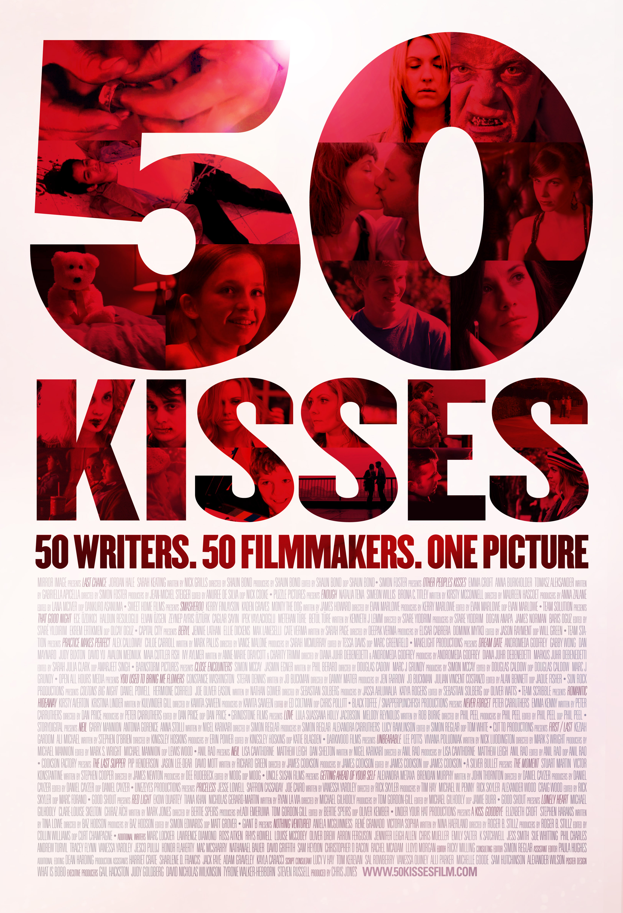

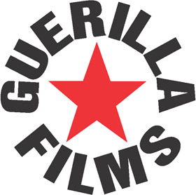
50 Kisses is released by Guerilla Films Ltd

Press Contact Details
Chris Jones, Director : chris@londonswf.com / Tel: 07977 516 628
Judy Goldberg, Press Contact : judy@londonswf.com / Tel: 07850 122 370
Website: www.50kissesfilm.com

Downloads such as further documents, video clips and photos are available from the press area on the site at…
http://www.50kissesfilm.com/press

50 Kisses Short Synopsis
Fifty Kisses is a crowd created feature film with multiple stories connected by one thing – a Valentines kiss. Irreverent, charming, ridiculous, moving and at times wonderfully profound, 50 Kisses features everything from love struck zombies, androids and teddy bears to… fatigue fighting lesbians! 50 Kisses is the world's first crowd generated feature film; a multi-cultural and global reflection of pop culture’s vision of love in the 21st century.

Long Synopsis: 50 Screenwriters, 50 Filmmakers…50 Kisses
50 Kisses is a groundbreaking project that brought together new talent in a global collaboration with the sole aim of creating an extraordinary feature film.

In the summer of 2012 the London Screenwriters Festival issued a challenge to the writing community – create a killer 2 page script that filmmakers anywhere in the world will work with you to produce. The best 50 of those films will then be woven together to create a feature length film that will receive a global release. The only guidelines were that the scripts be set on Valentines Day and feature at least one kiss. Out of 1870 script submissions and 127 completed films, the result is 50 Kisses, a ground breaking film showcasing the combined talents of hundreds of new creative voices from around the world.

Irreverent, charming, ridiculous, moving and at times wonderfully profound, 50 Kisses features everything from love struck zombies, androids and teddy bears to… fatigue fighting lesbians! 50 Kisses is the world's first crowd generated feature film; a multi-cultural and global reflection of pop culture’s vision of love in the 21st century.

Background
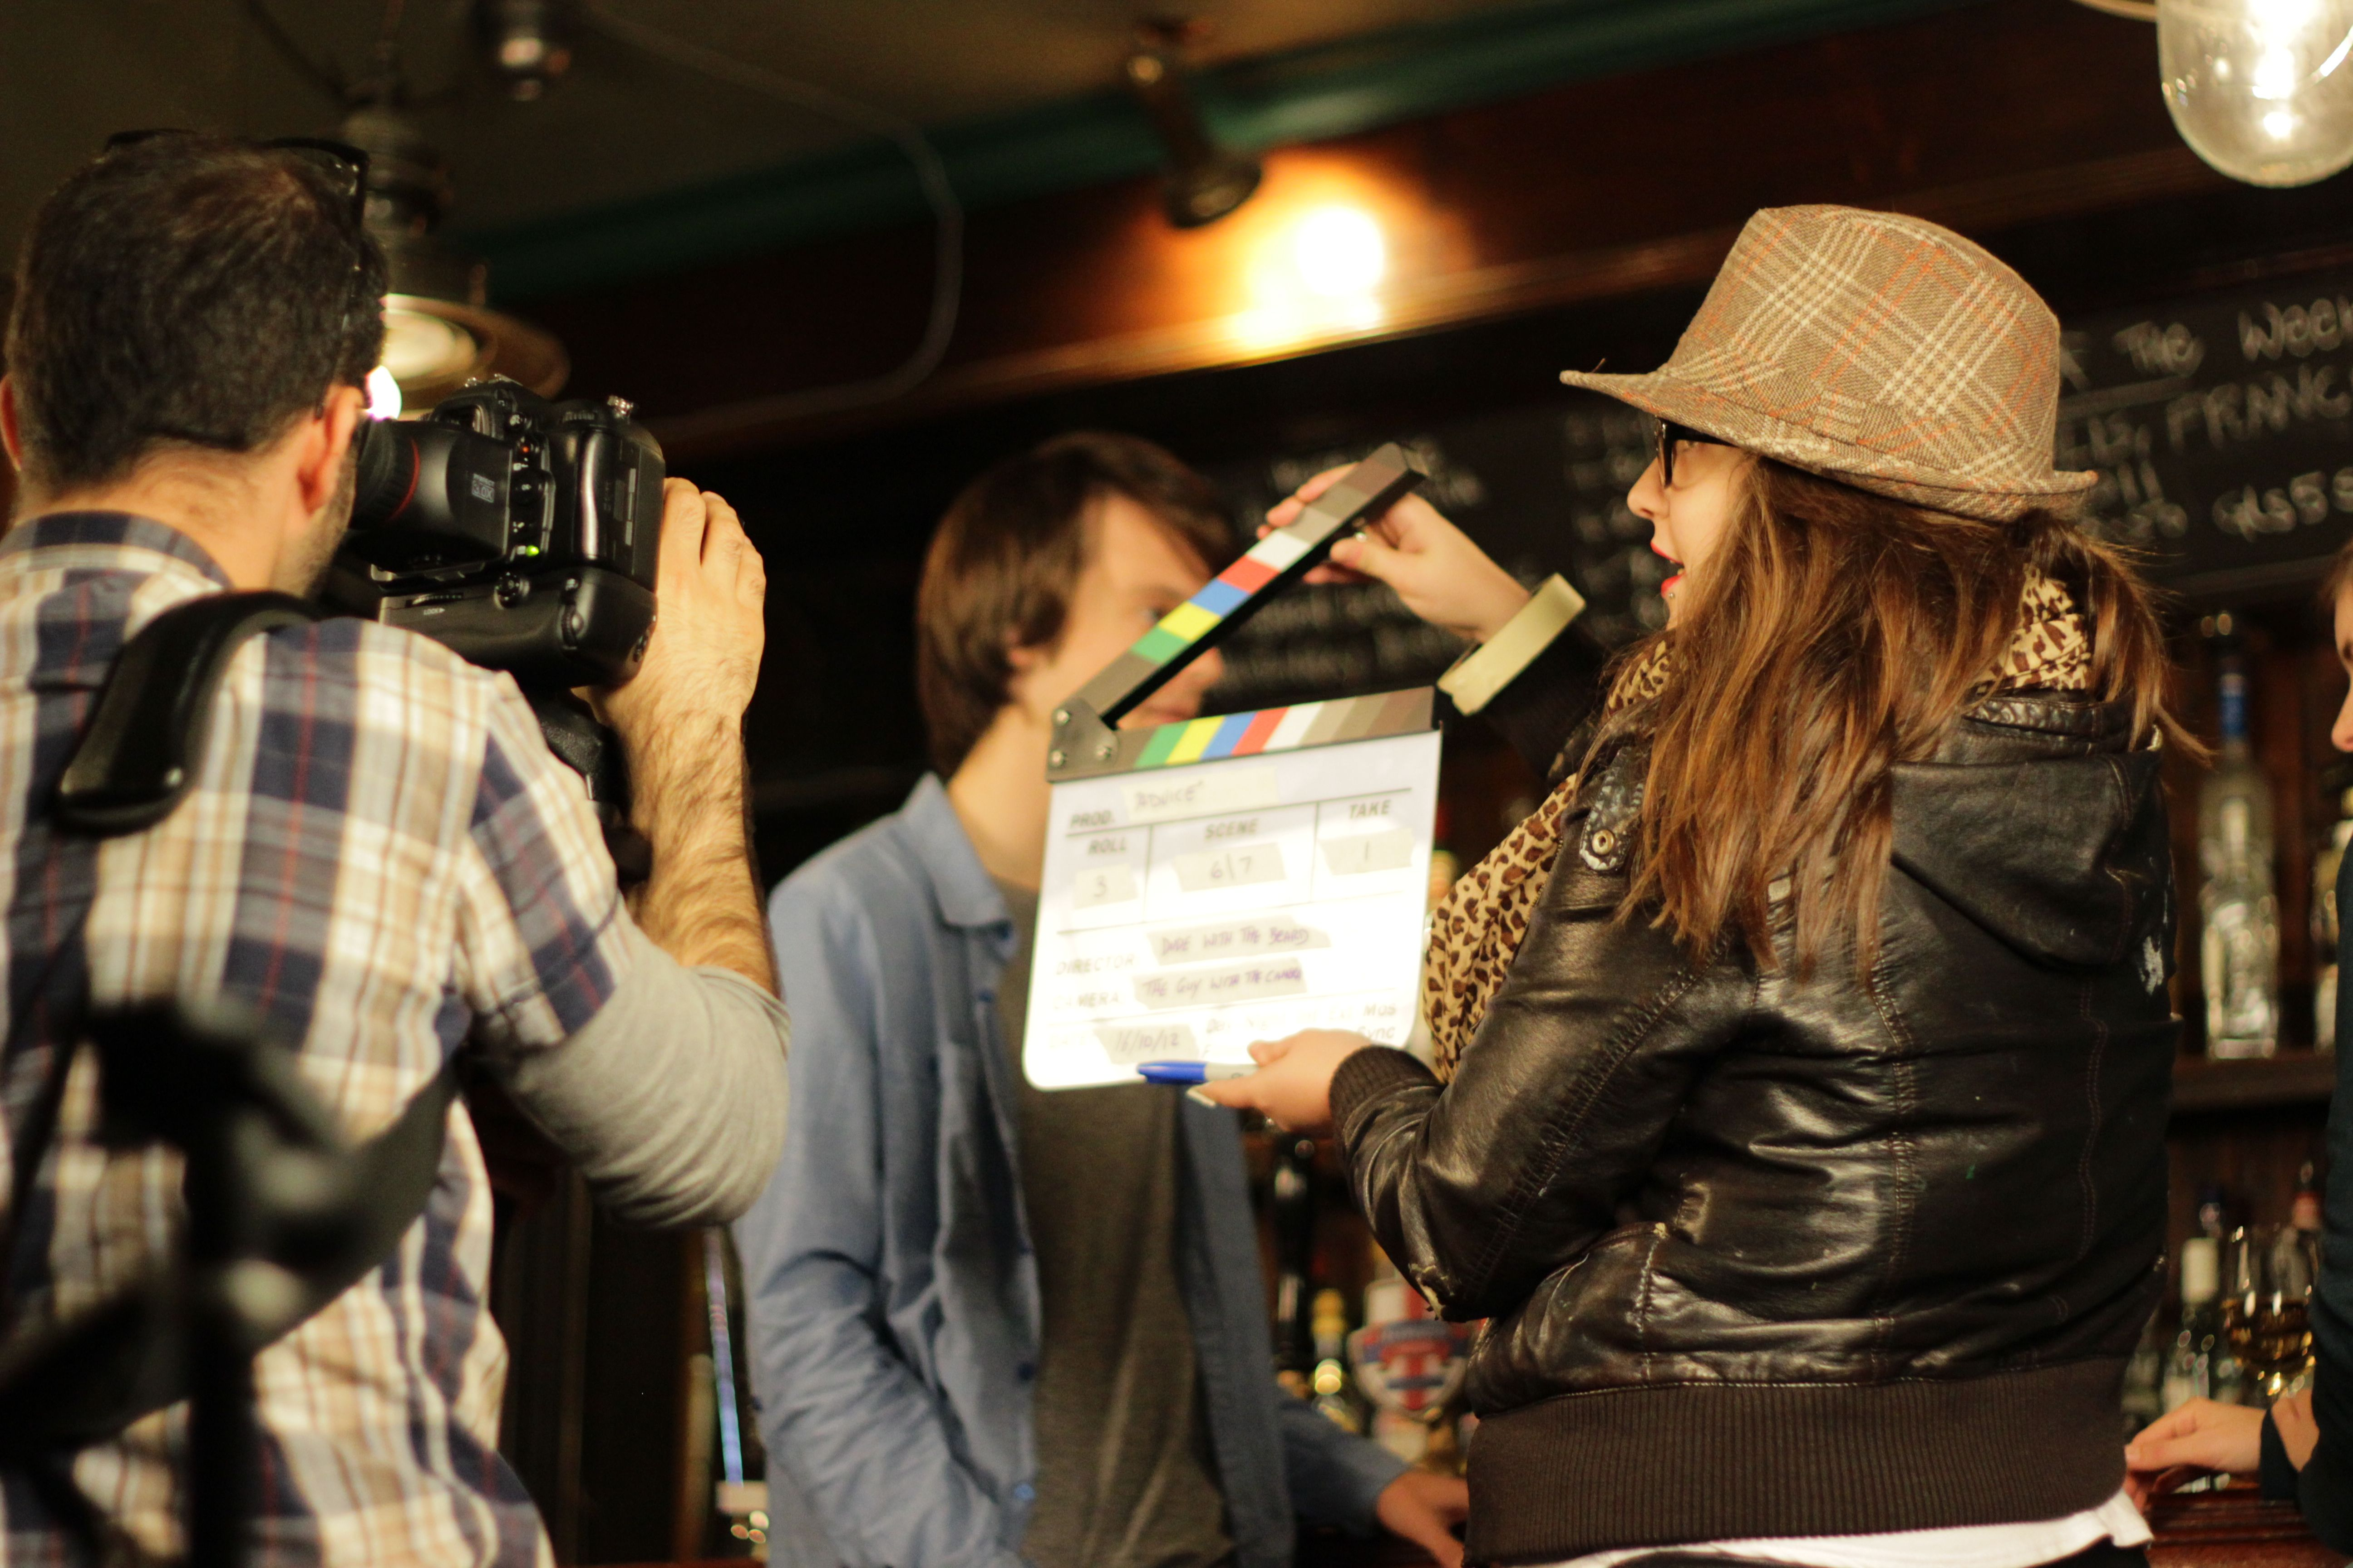
50 Kisses is the culmination of 2 years work, 1870 scripts, 127 films, untold man hours and one vision – to get writers writing and filmmakers making films.

50 Kisses features 127 films made exclusively for the project – all set on Valentine’s Day and containing a kiss. All 127 of the submitted films feature in the film in various contexts with the best 25 presented in their entirety. The film proudly showcases upcoming writing, directing, songwriting and acting talent from around the world.

The London Screenwriters Festival is the driving force behind this unique project. Keen to give writers a ‘real life’ opportunity to work with directors, and get their films made, they launched the 50 Kisses project in May 2012.

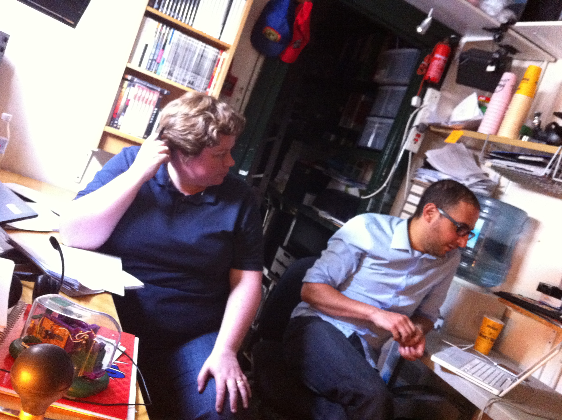
The Writers Challenge… It always starts with a script
It started with a competition launched initially through the London Screenwriters’ Festival community; the challenge quickly went viral with entries being submitted from all corners of the globe. Out of 1870 submissions a team of a dozen professional script readers, all volunteering their time and services in return for an IMDB credit, whittled down the pile and created a shortlist of 100, all of which were read, scrutinized and deliberated over until the final 50 winners were selected and announced.

Project co-ordinator and director Chris Jones reflects “Like all acts of creation, there is a great deal of naïveté and madness involved. We hugely underestimated the workload from the engagement we received from the screenwriters.”

50 Kisses producer Judy Goldberg adds, “very quickly we realised that we had a tiger by the tail, an idea that creative people really connected with, and it was going to be a real challenge to see it through with zero budget backed up only by tons of enthusiasm and passion from the team and community.”

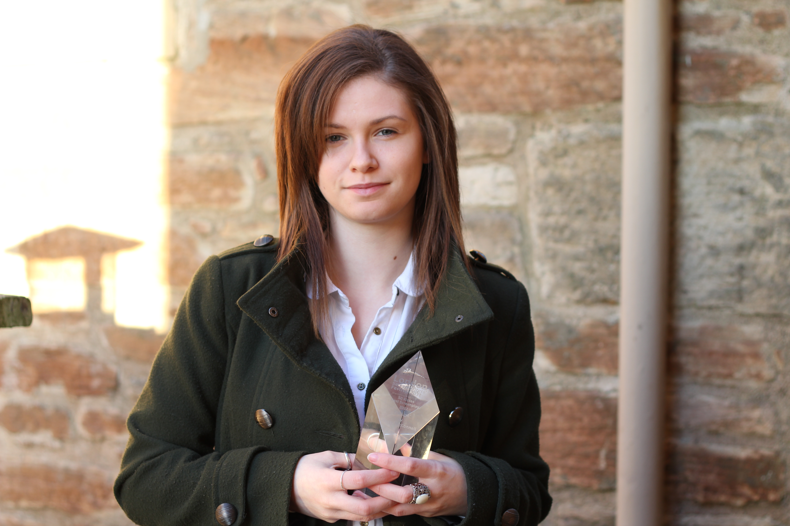
The overall winner of the writing competition was Scottish based Kirsty McConnell who penned the poignant and moving ‘Enough’ which proved to be one of the most popular selections for the filmmakers and inspired 9 different teams to create their versions. Kirsty was presented with her award by Producer Chris Jones during the Keynote Speech at the London Screenwriters’ Festival 2013.

Screenwriting Legend John August (‘Big Fish’, ‘Charlie’s Angels’, ‘Charlie and the Chocolate Factory’) said of the script “What I like about “Enough” is that such a simple scene outlines such a complicated--but familiar--situation. We're invited to figure out what happened and what these characters want in the aftermath of an offscreen revelation. The resulting kiss is both unexpected and justified”

‘Death at a Funeral’ Writer Dean Craig said “The script manages to be intriguing, relatable, emotionally resonant and surprising, and best of all it feels real. This is a writer with great instincts”

Development: The collaboration begins
With the winning scripts clearly at various different stages of development, some were first drafts selected on the strength of the concept and writing, while at the other end of the spectrum some were third, forth or fifth drafts; tight, polished and confident.

The 50 Kisses process was about to take a big and bold evolutionary step, to engage the community in the process of feedback and improving the screenplays.

All winning scripts were posted on the website and we invited the rest of the community, including those writers who’s scripts were not selected, to comment and share their professional opinions on the winning scripts.

Meanwhile behind the scenes, the Producers worked closely with the reading team and spoke with each of the fifty winning writers offering what, for some of them, was their first set of ‘Producer’s Notes’. These notes were also uploaded to the website (again for the entire community to comment on) with ALL of the winning writers urged to write further drafts and keep polishing and improving on their material.

Thus the global conversation and, most importantly, the collaboration had begun. Executive Producer and script reader Gail Hackston commented “No other screenwriting and filmmaking initiative has ever offered this level of feedback and engagement.”

Read all the 50 Kisses two page scripts on the site here…
http://www.50kissesfilm.com/50-kisses-the-screenplays/

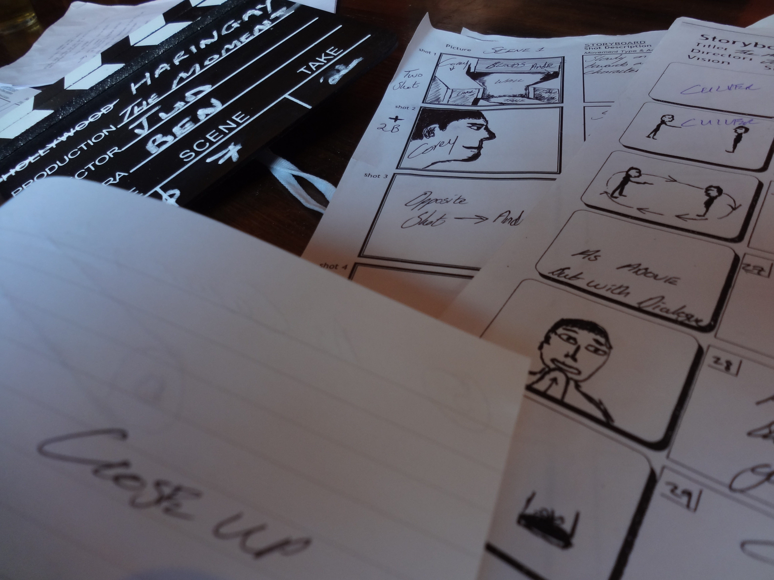
The Filmmakers Challenge: Visualising the scripts:
While the writers were writing, tightening and re-writing their scripts, 400 filmmakers around the world were waiting in the wings.

All of these filmmakers had been issued with their own challenge, to select the script (or in some cases more than one) which resonated with them the most and produce the best possible version of those scripts that their resources and abilities would allow.

All of the filmmakers were encouraged to collaborate with their writers and in some cases, further drafts were produced as a result of these conversations. Within two months, 127 of the 400 filmmaking teams had committed to their projects, taken steps, picked up a camera, gathered their teams and shot, edited and submitted their movies.
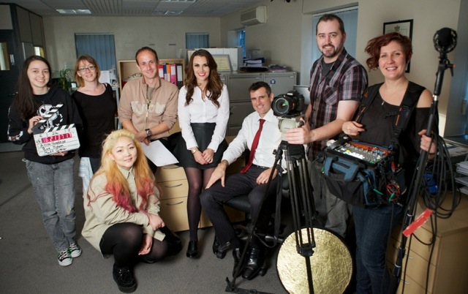
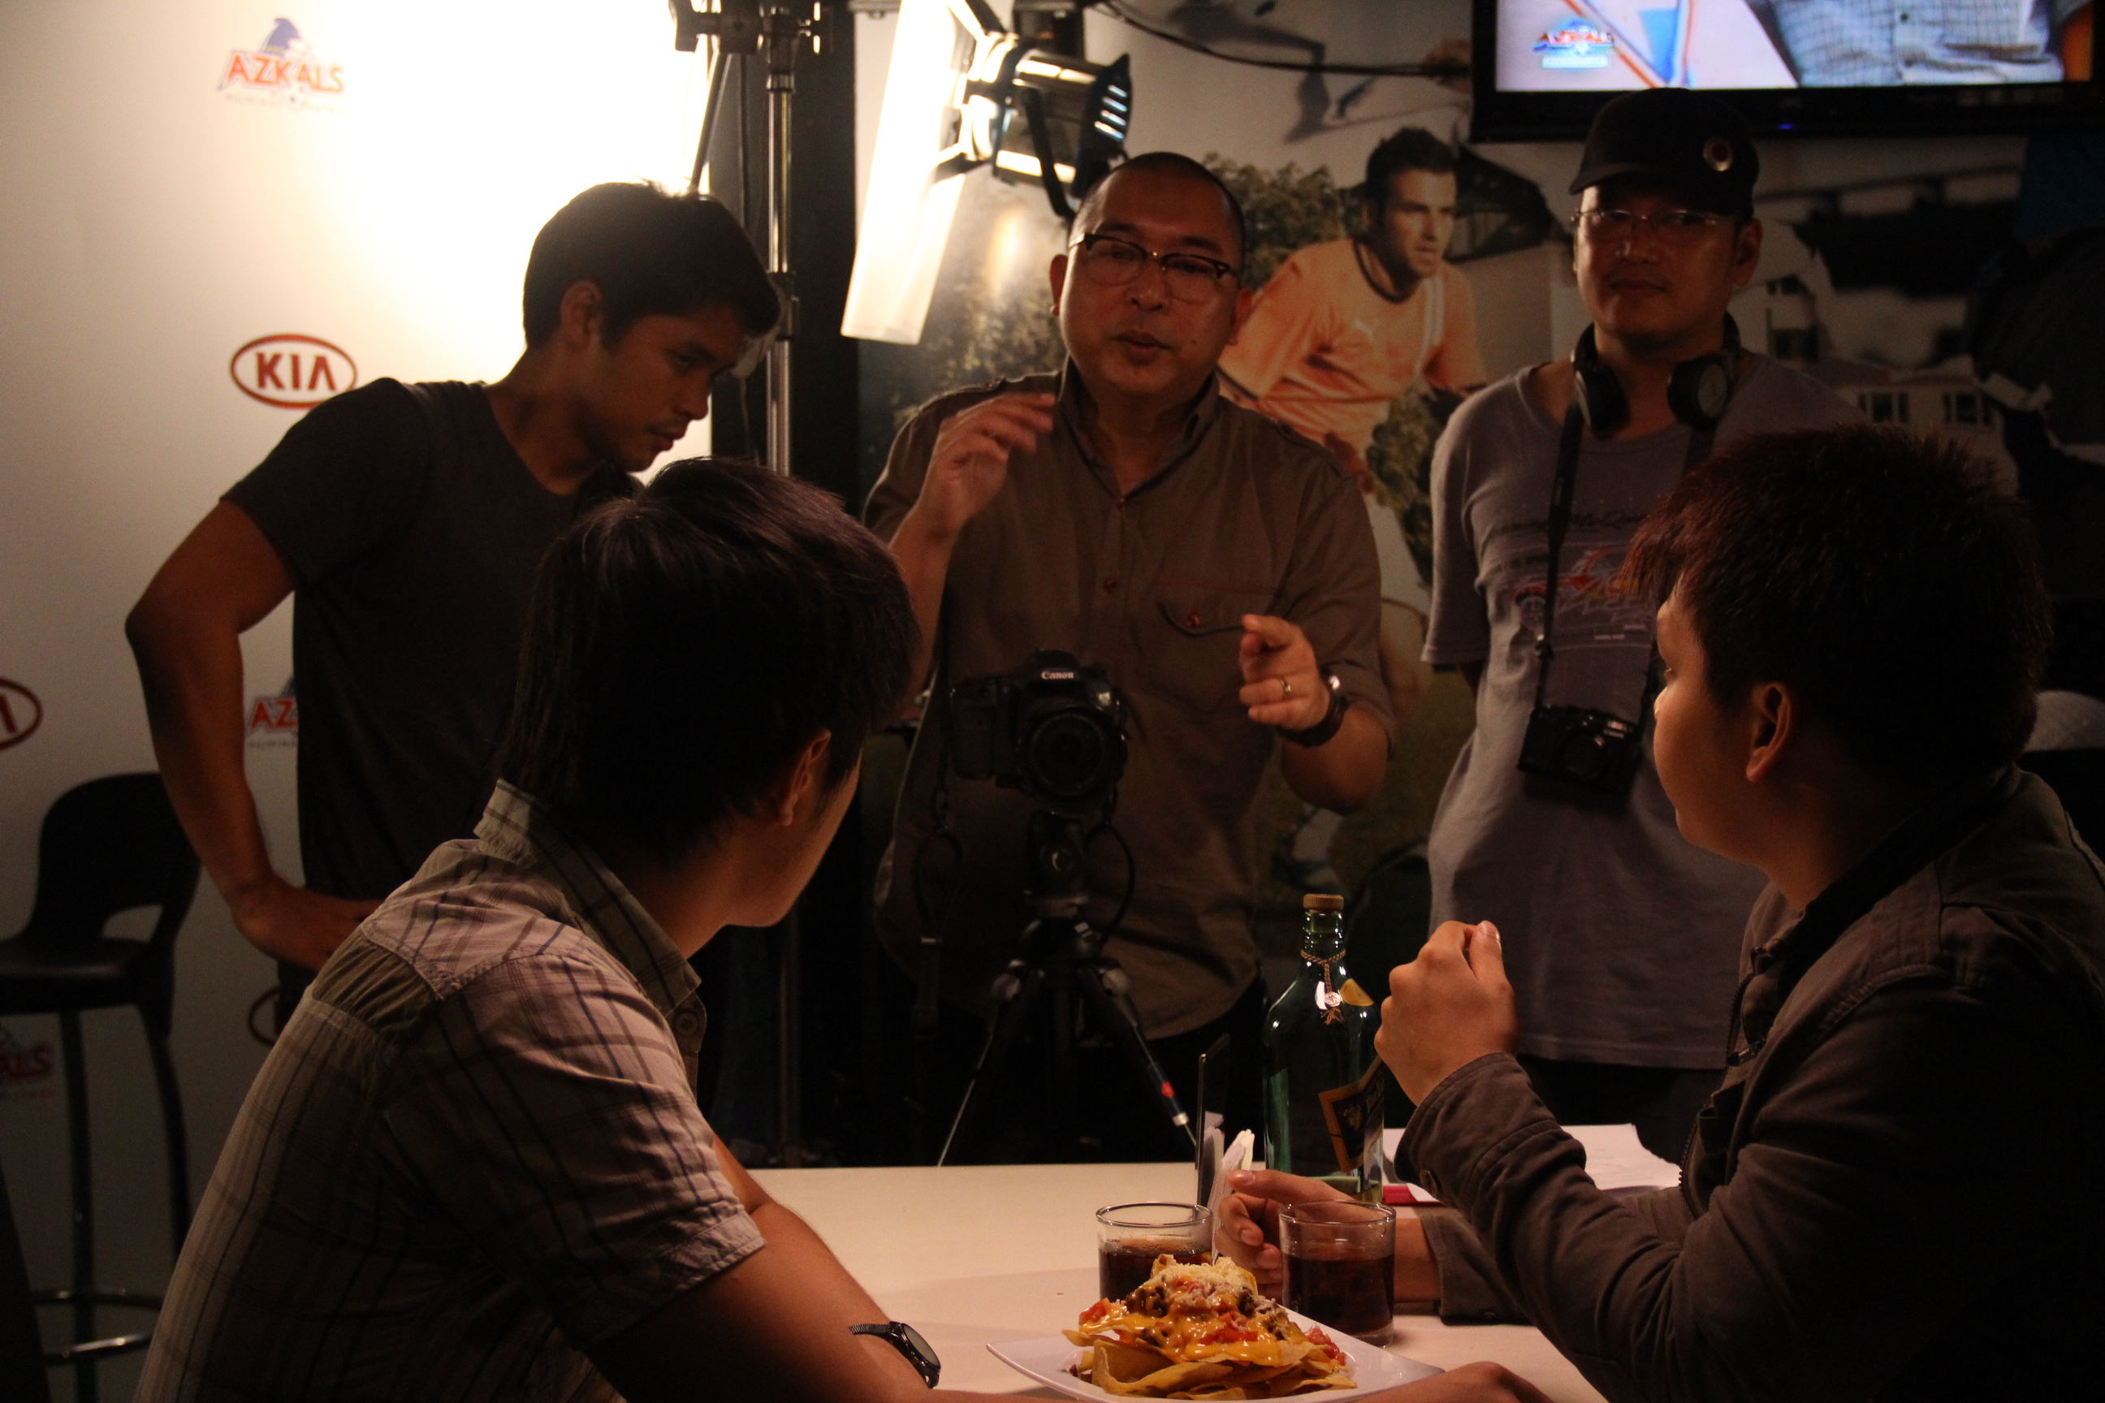
In keeping with the ethos of the project, the filmmakers were encouraged to share their completed films on the 50 Kisses website and the community was invited once again to offer comments – both positive and negative – which the filmmakers could choose to either take on board or dismiss. Of the 127 submitted films, 100 were uploaded to the website; with some filmmakers opting to decline in favour of taking their films down the festival route instead.
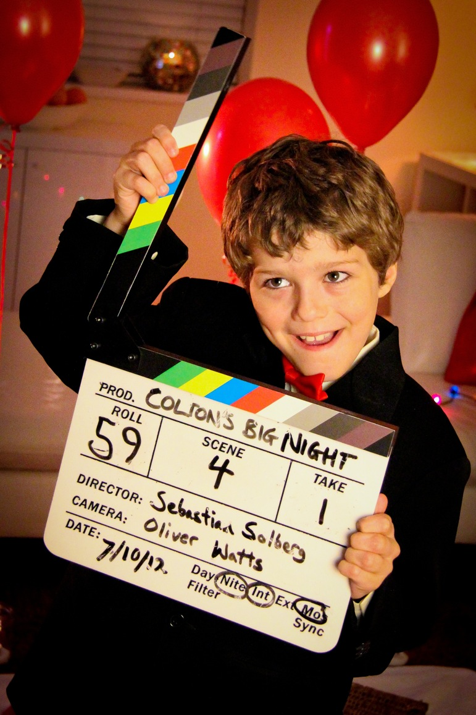
Similarly to the process the writers underwent, the filmmakers received ‘Producer’s Notes’ on their ‘First Cuts’ and were encouraged to re-edit and submit a refined final cut.

Stand out examples of filmmakers who fully embraced the process and went on to deliver winners in their categories are ‘Beryl’ by Deepak Verma (Capital City) (view here http://www.50kissesfilm.com/movies/beryl-by-capital-city/) and ‘Smasheroo’ by Evan Marlowe (Sweet Home Films) (view here http://www.50kissesfilm.com/movies/smasheroo-by-sweet-home-films-llc/)

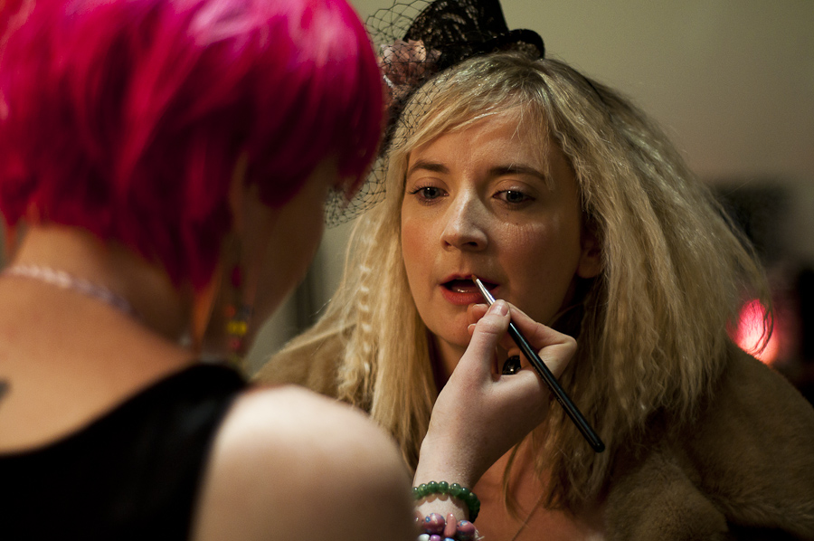
Further standing as testimony of the high quality of films created from the project are ‘Love’ by Phil Peel and ‘Dream Date’ by Andromeda Godfrey, both of which feature in their entirety in the film and both of which have gone on to win awards outside of this project. Rom-coms, zom-coms, thrillers, sci-fi, dramas, coming-of-age, erotic stories of love, hate and every shade in between, from impactful emotional stories with a heart, to flesh eating zombies eating hearts – 50 Kisses has it all.

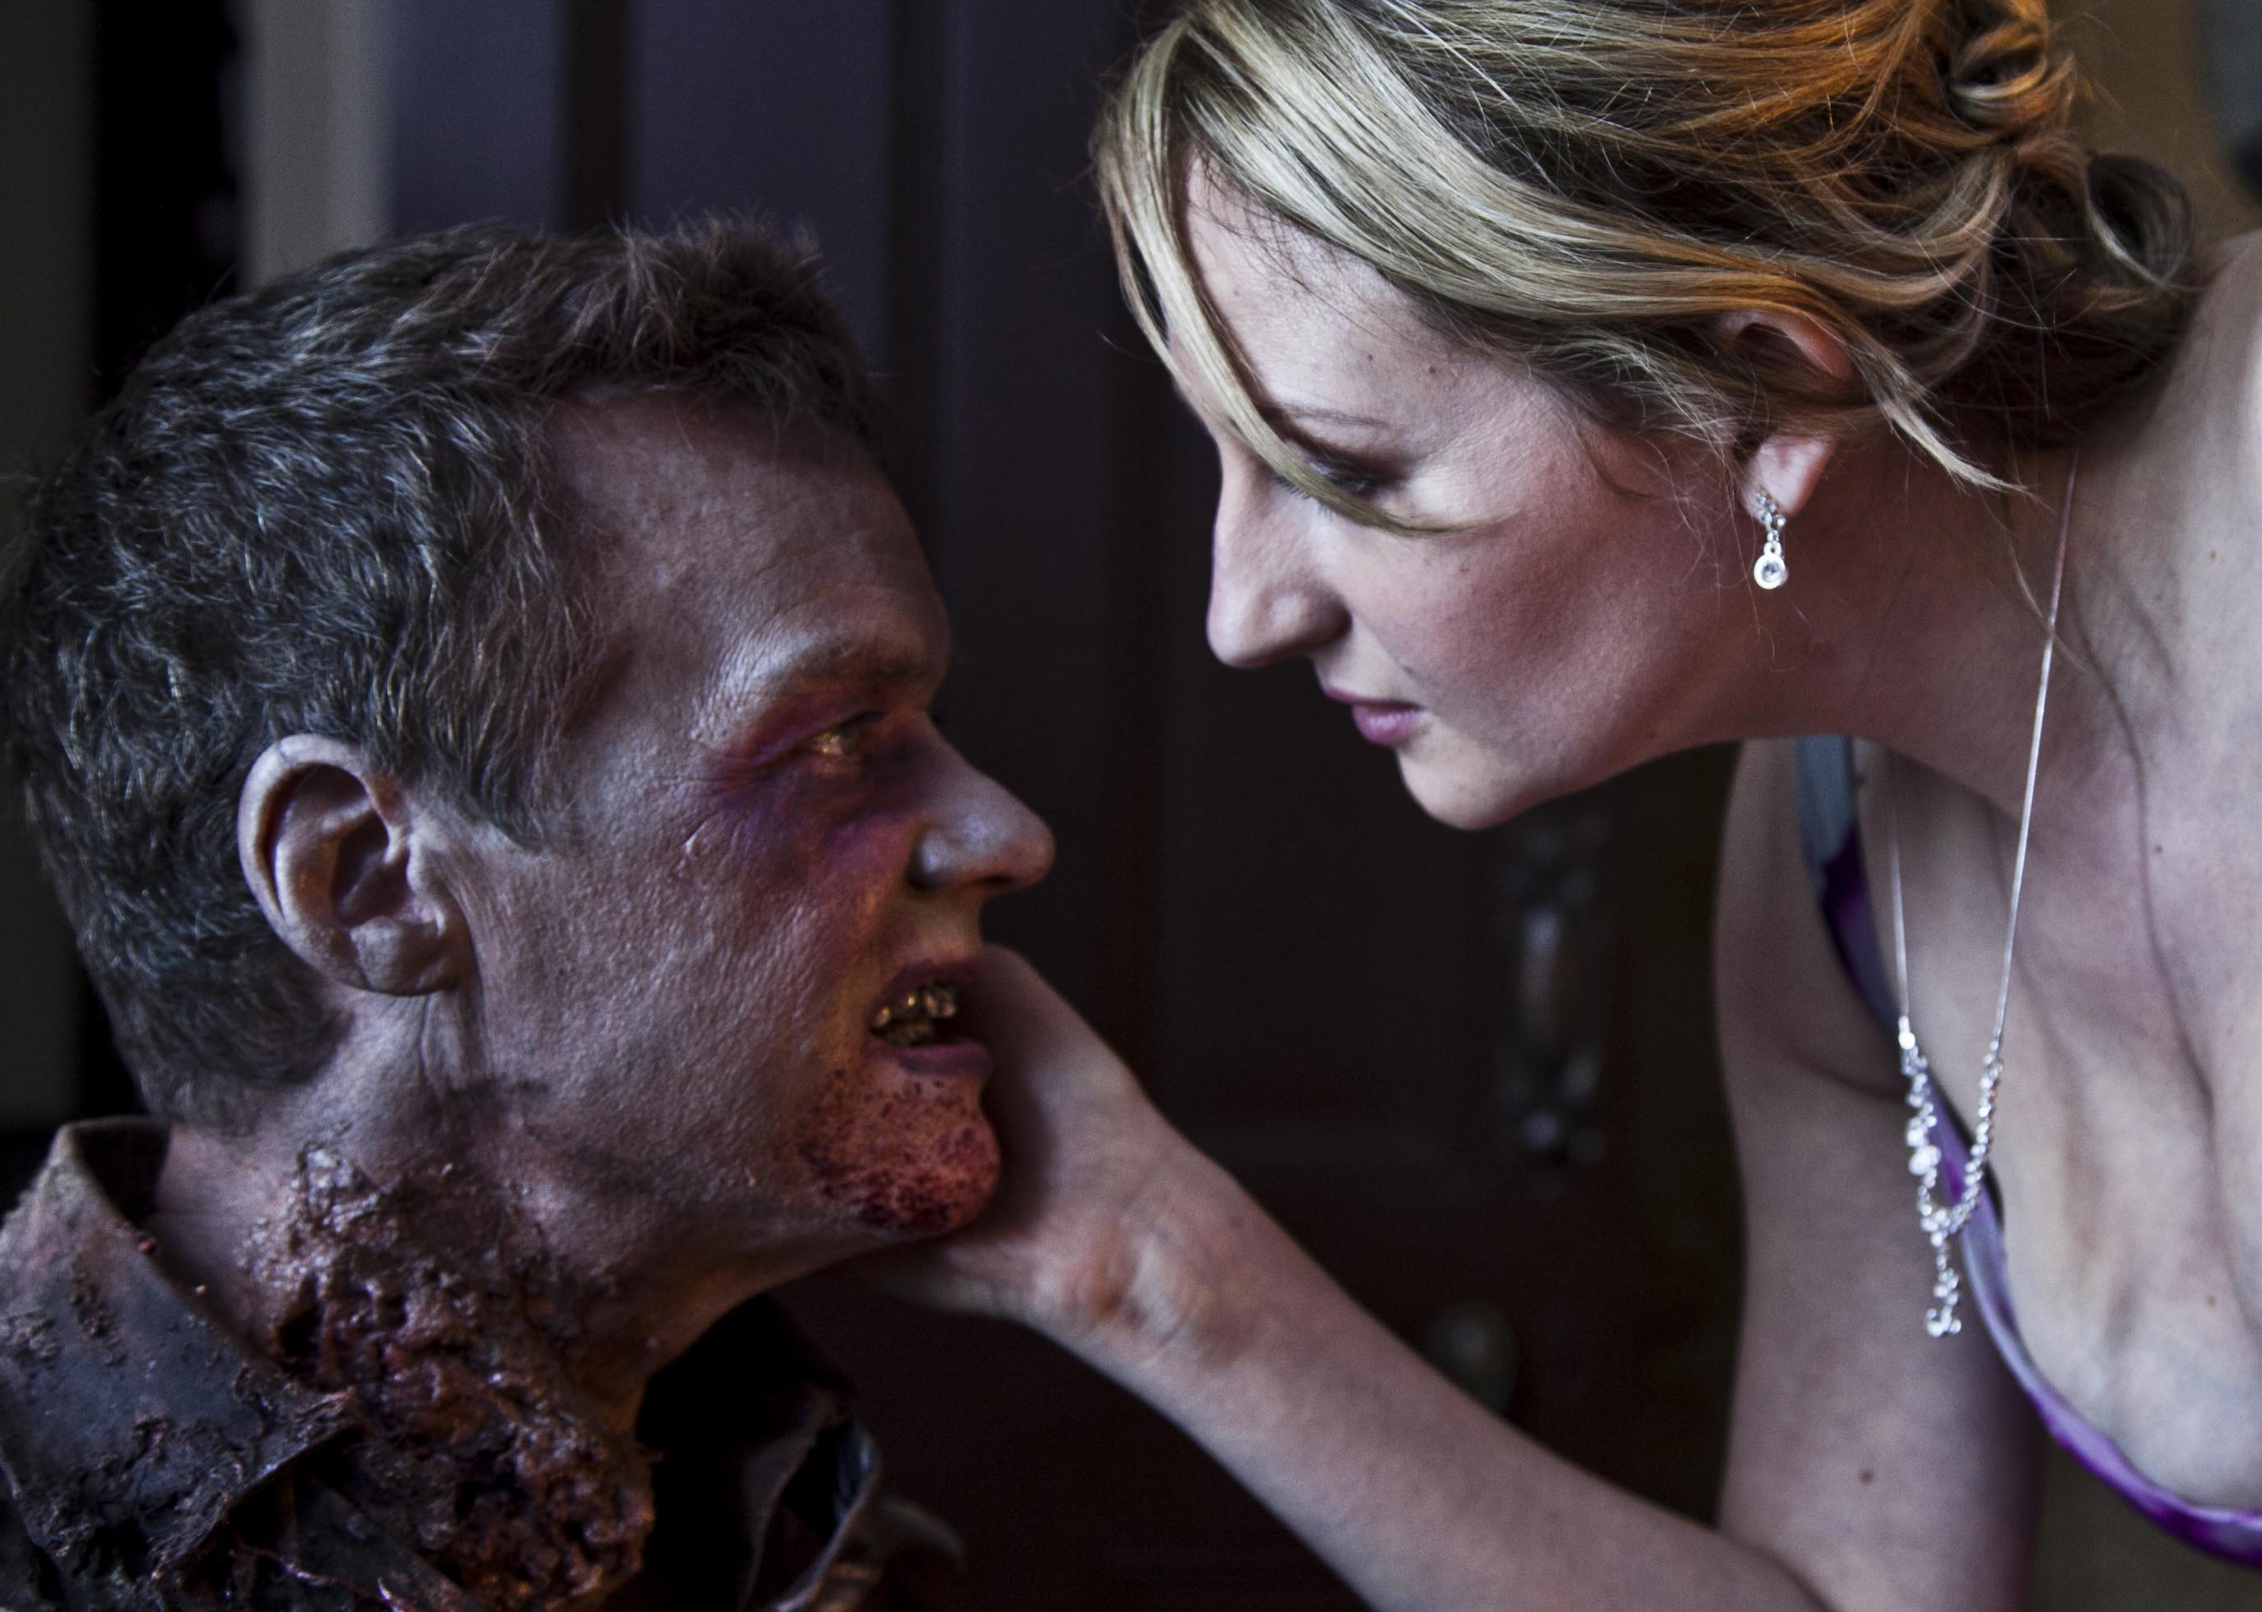
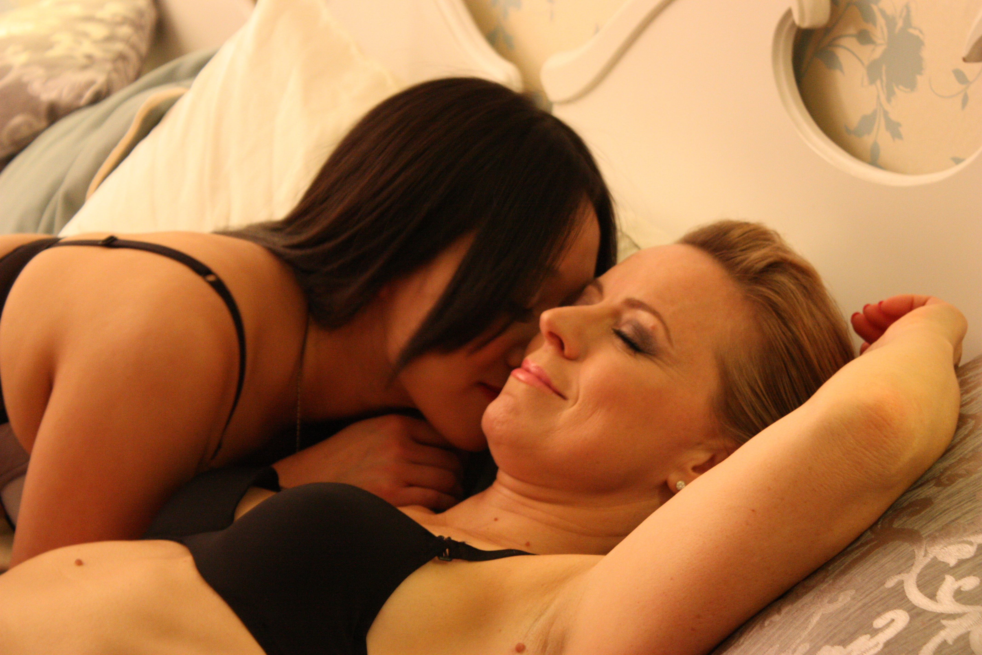
Project Director Chris Jones adds, “All the filmmakers who actively engaged with the feedback process radically improved their films by re-editing and in some cases additional shooting. We wanted to go beyond what most competitions offer, we wanted the community to be active participants in each others learning and success. You can see this clearly in the feedback offered, film maker to film maker, on each of the films pages on the site.”

Check out all the films submitted to 50 Kisses on the site here…
http://www.50kissesfilm.com/movies/

The Songwriters Challenge: What is a film without music?
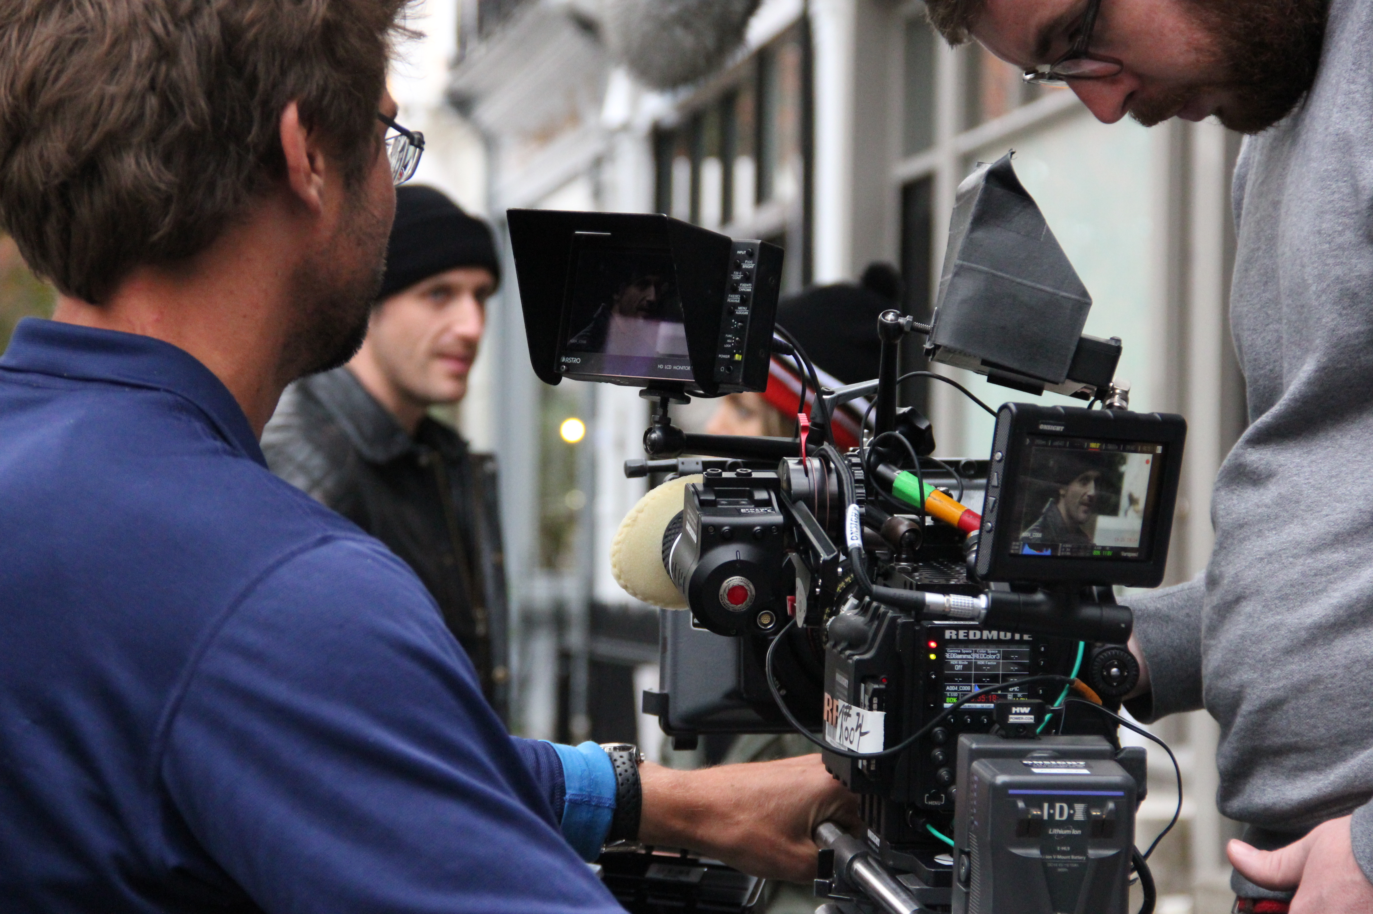
In addition to the scripts and the films, we crowdsourced all of the music from independent artists and musicians who submitted their work for consideration, with 12 original tracks being selected to feature in the final film.

You can listen to the 50 Kisses soundtrack online now here…
http://www.50kissesfilm.com/music-challenge/
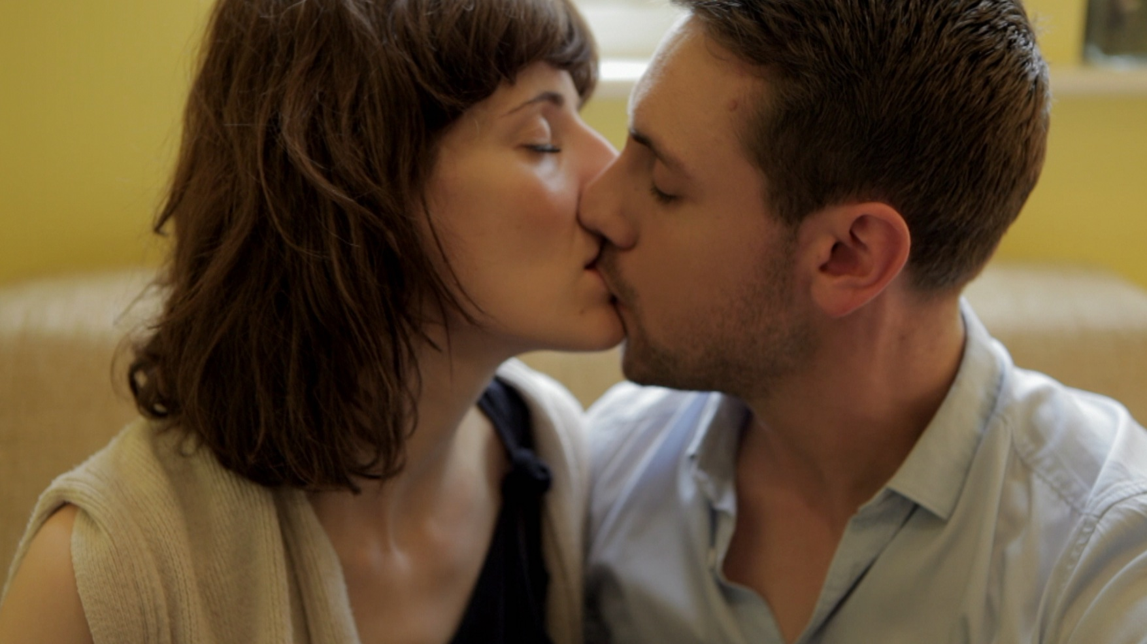
The Challenges (aka, what we didn’t know we didn’t know):
While the original remit of the project was to find 50 scripts, have them made into 50 films and lace them together into a feature. We discovered very quickly that (a) not all the scripts had been made and (b) that some that had been made were not of the quality a cinema going audience would expect, while others were world class.

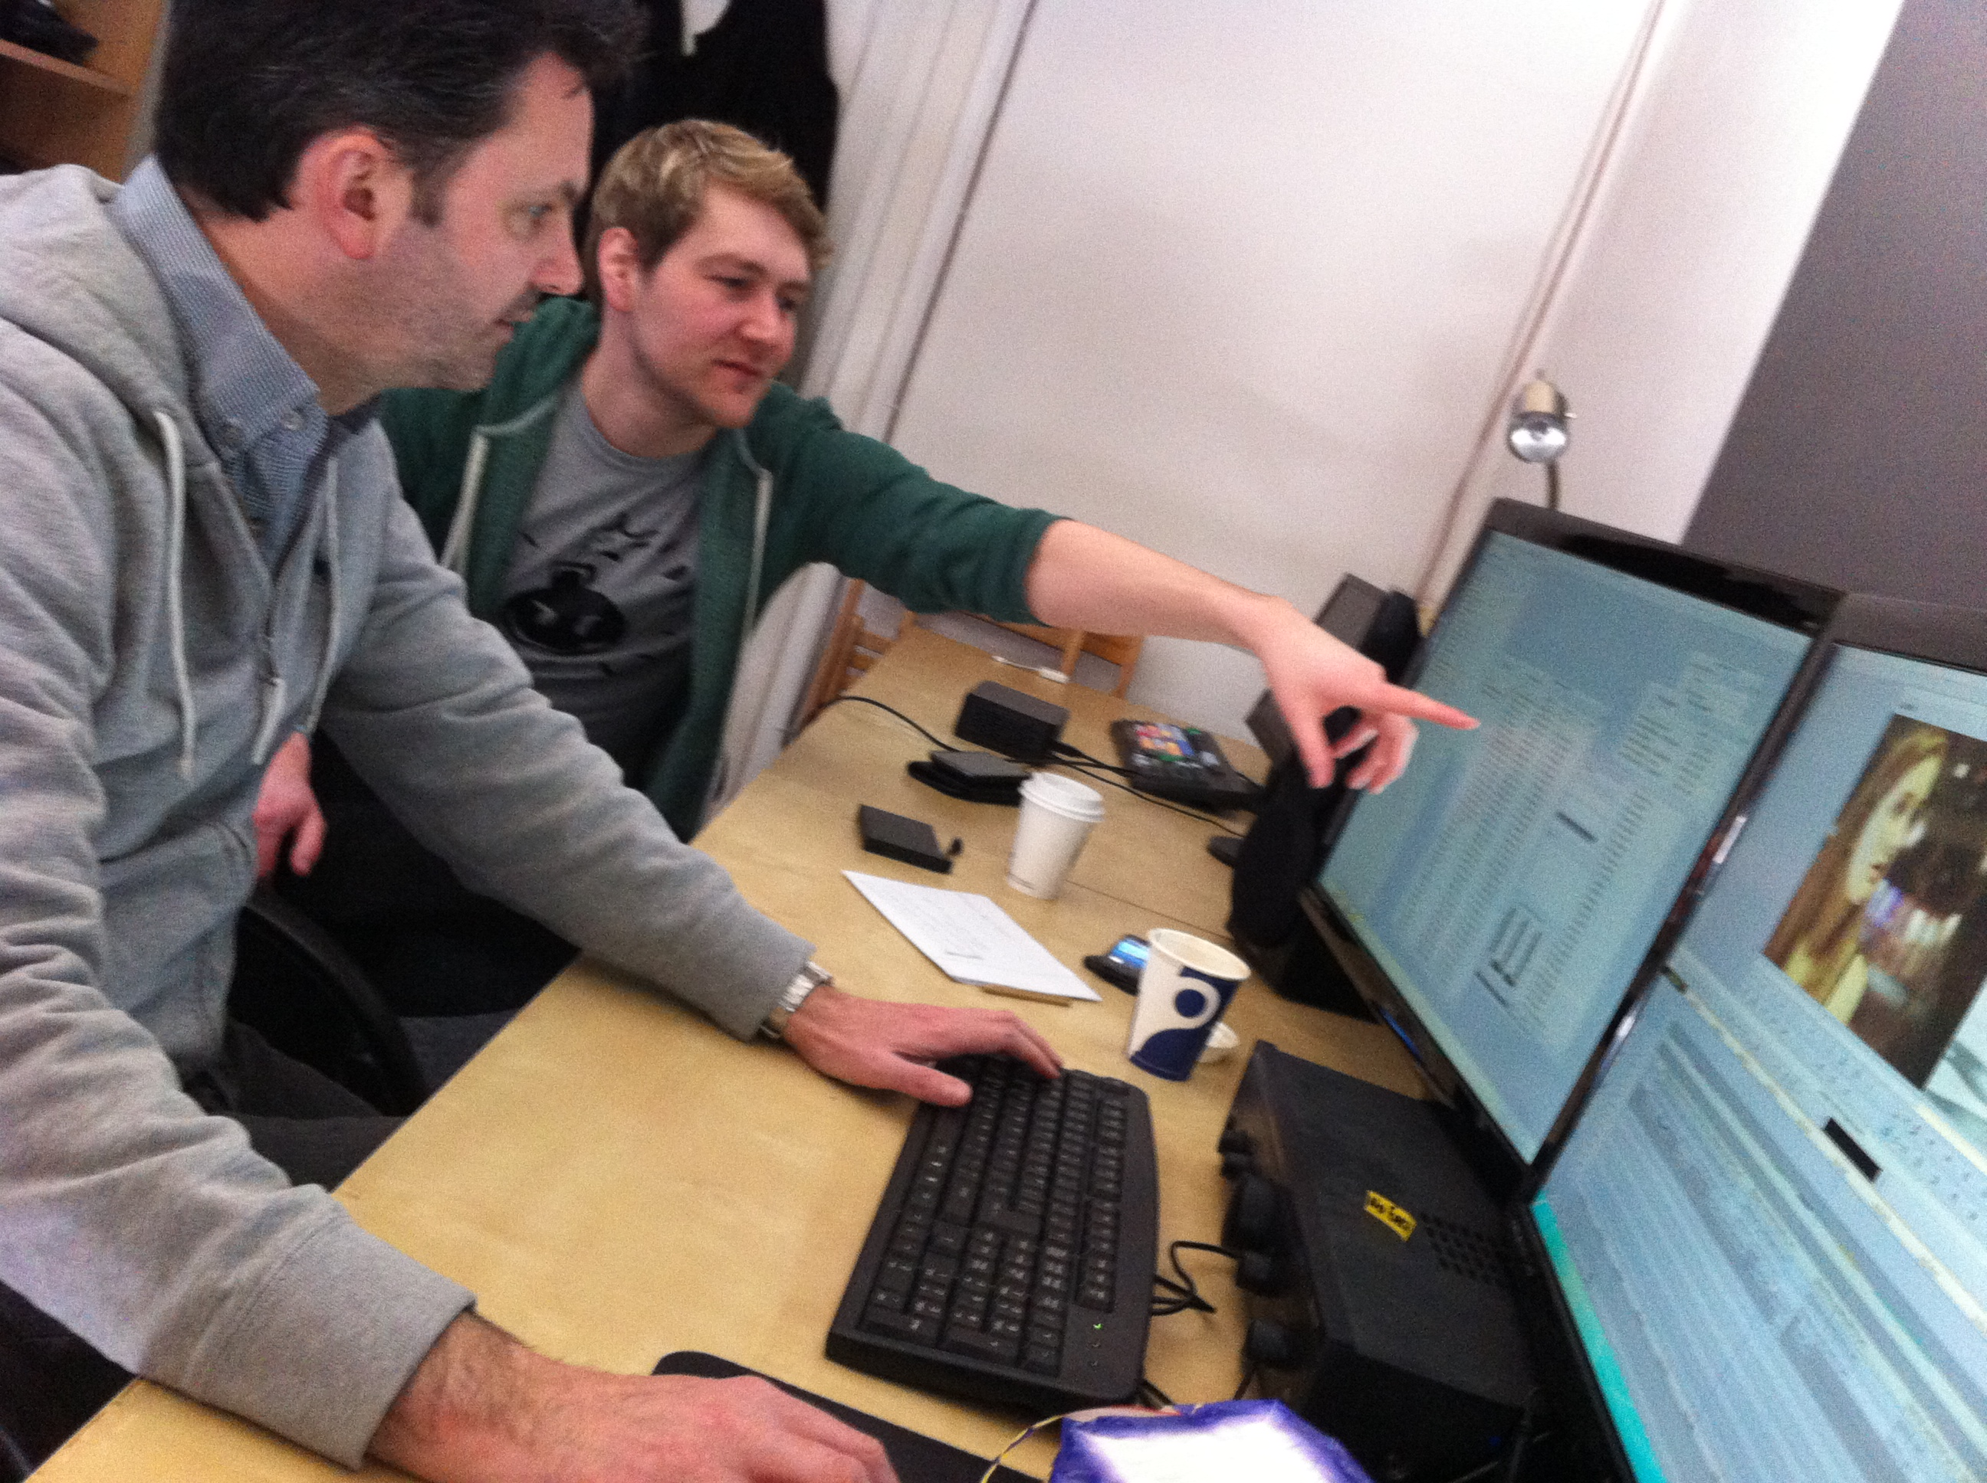
The Solution:
After much deliberation within the Production Team, we decided (again, in keeping with the spirit of the project) to consult with the community.

The question posed - is it more important to fulfil the promise that 50 films would be featured OR to deliver the highest quality and best possible version of this feature film that we can? The answer was immediate and unanimous; 50 Kisses should be the best that it can be. So some hard decisions were made and even harder conversations were had but eventually the best 25 of the submitted shorts were selected to be presented in their entirety in the final film.

Out of the 25 featured films, one winner will be selected as ‘Best Picture’ at the 50 Kisses Awards to be presented during Premiere on 13th February 2014 in London.

Olivia Hetreed, Head of the UK Writers Guild and writer of the Scarlett Johansson period drama ‘The Girl with the Pearl Earring’ will be handing out awards to the writers on the night. She adds, “I love the idea of ‘50 Kisses’, there is no better way for a screenwriter to learn the craft than to have their words become film. It's what it's all about."

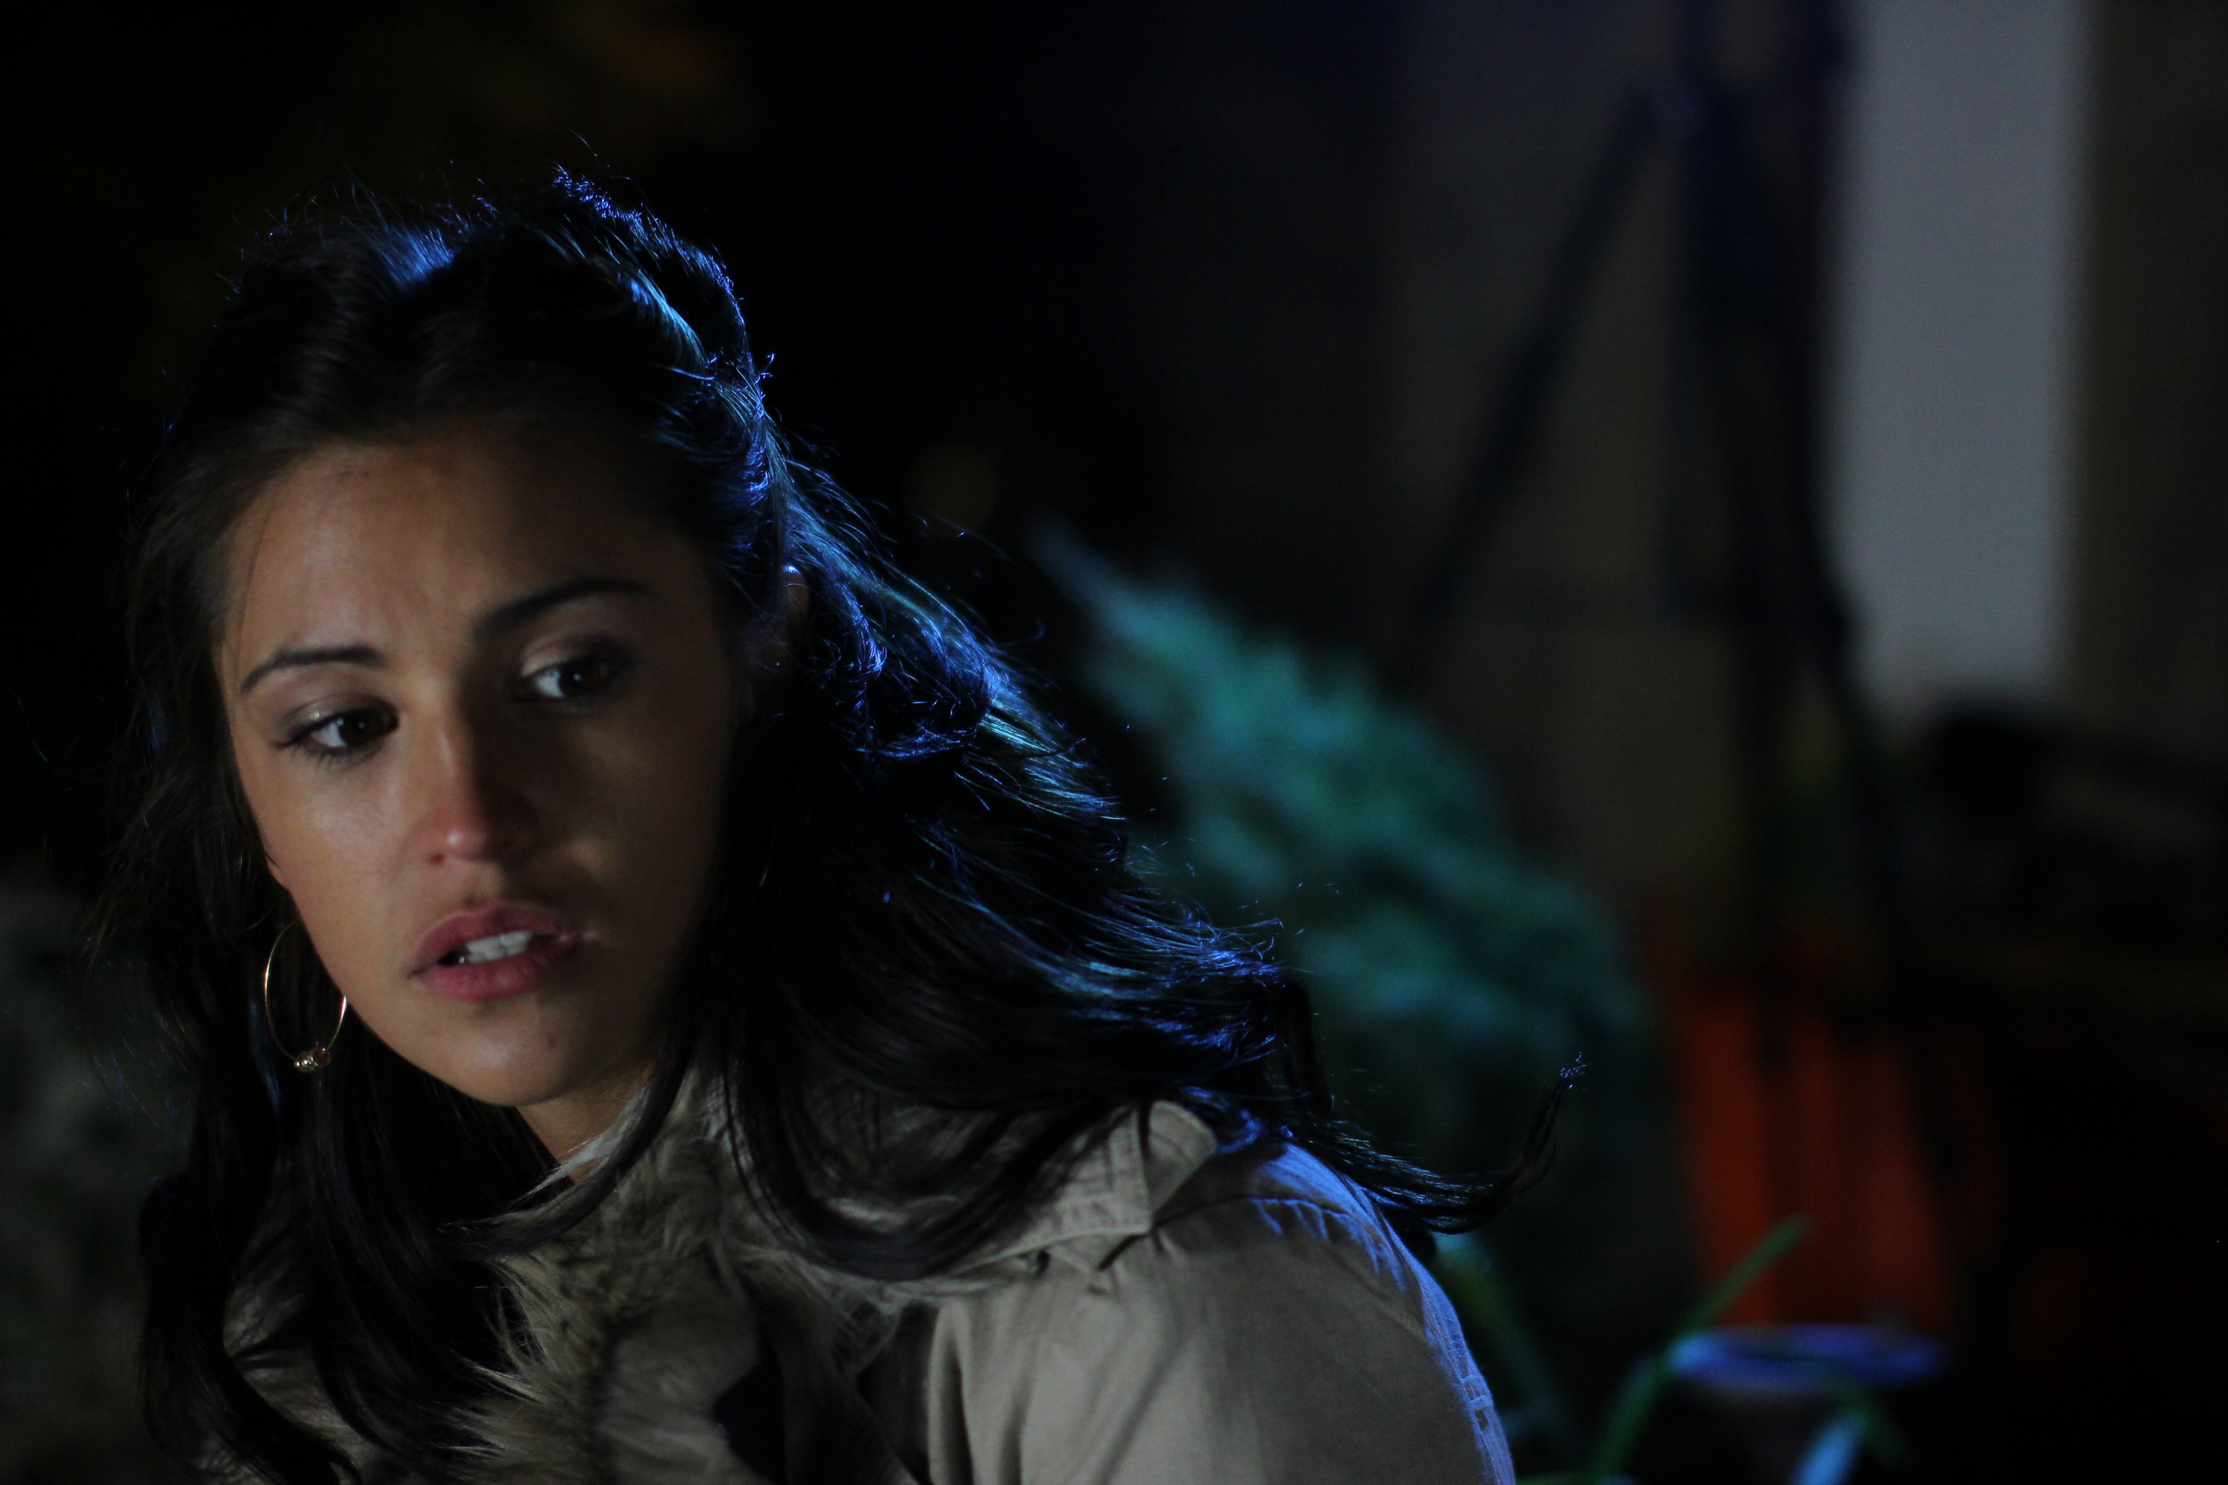
All writers and filmmakers contributed to the 50 Kisses feature film in exchange for an IMDB credit.

50 Kisses receives it’s world premiere on 13th February at the Genesis Cinema in London.

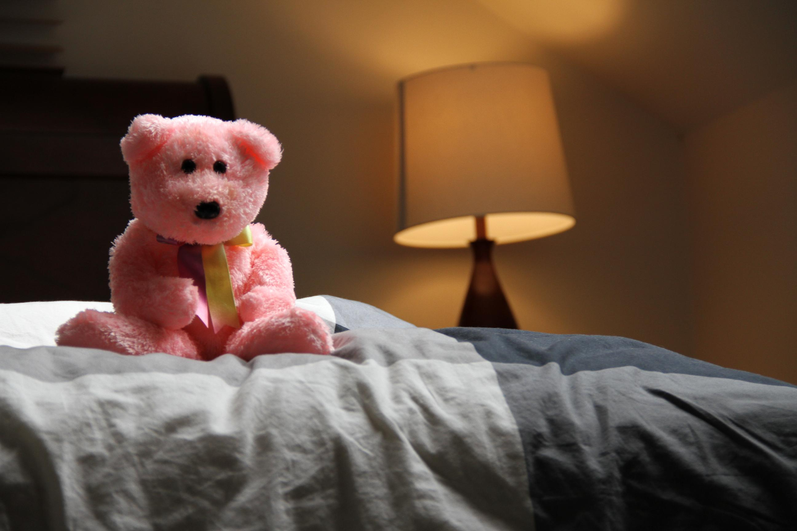
With over 400 people expected to attend, 50 Kisses stands to make a significant impact on the UK Box Office figures for the weekend 14th February 2014.

Simultaneous screenings supported by the 50 Kisses production team
will take place in locations around the world as far away as California, Kansas, Kentucky, Washington, Texas, Australia, Zurich, Scotland, Puerto Rico, Canada, Tel Aviv, Columbia and the Philippines.

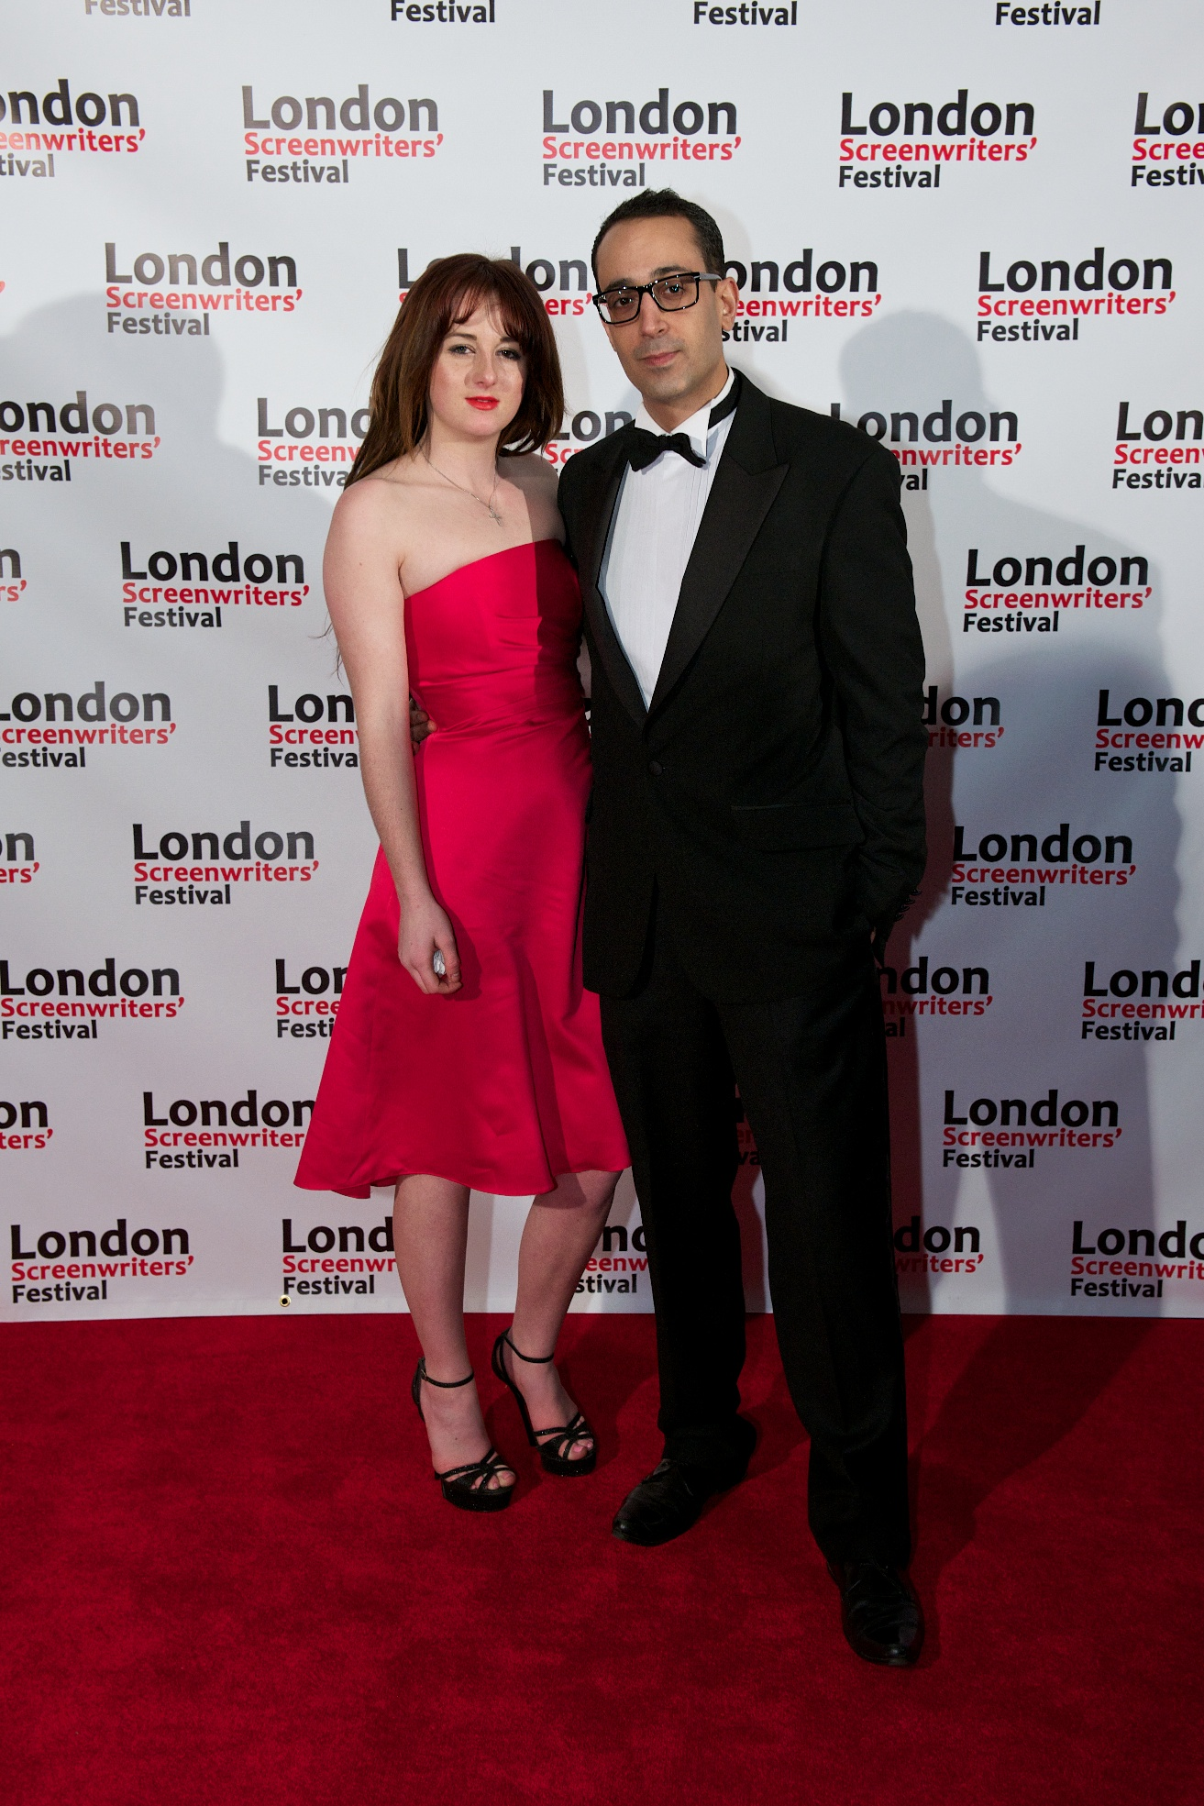
Update – Feb 2014:
On February 13th 2014, just in time for Valentines Day, over 500 people converged on the Genesis Cinema in London’s East End to attend the black tie World Premiere of 50 Kisses.

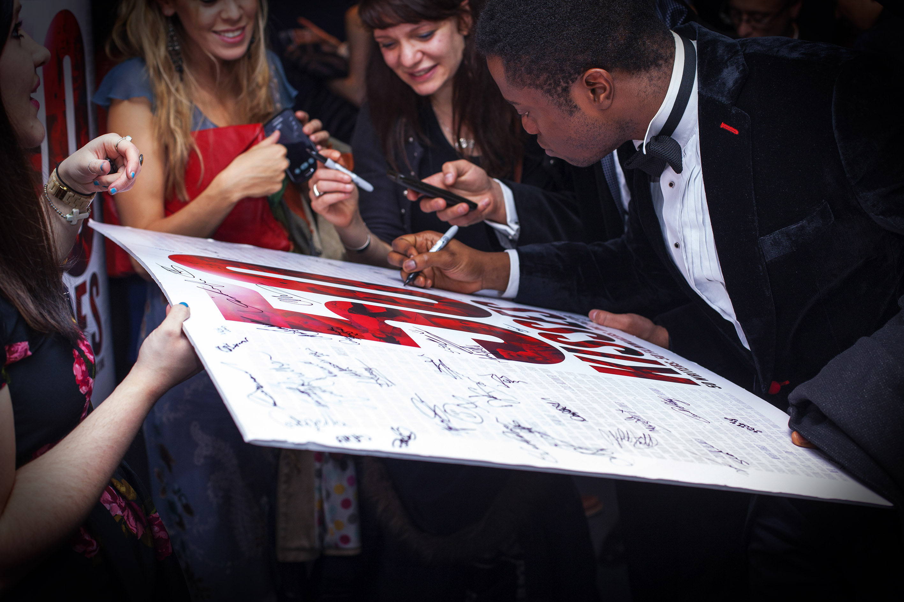
The atmosphere was electric as excited screenwriters, filmmakers, actors, crew, friends, family and members of the general public walked the red carpet and posed for professional photos at the official 50 Kisses step and repeat banner alongside decadently glamourous burlesque girls (courtesy of Wam Bam!, London’s Premier Burlesque Club).

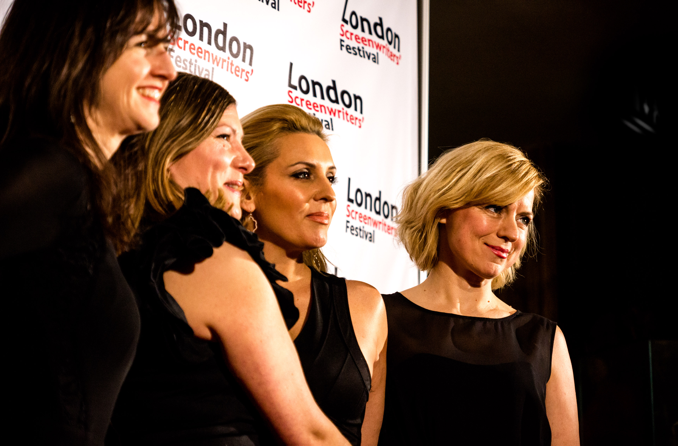
Drinks in hand the audience took their seats, filling to capacity Screen number one at the Genesis. 50 Kisses director Chris Jones took to the stage and kicked the evening off in style, acknowledging all the creative involved for their participation in this ground breaking venture. First up were the Screenwriter awards where President of The Writer’s Guild of Great Britain, Olivia Hetreed read out the names of all 51 writers were individually recognised for their contribution, those present gathered on stage to accept their awards and pose for a special group photo.

Next Adrian Wootton, CEO of Film London took to the stage to present the 25 winning filmmakers with their awards. Once again the stage was filled as directors and producers brought their cast and crew into the spotlight to bask in their moment in another special group shot.
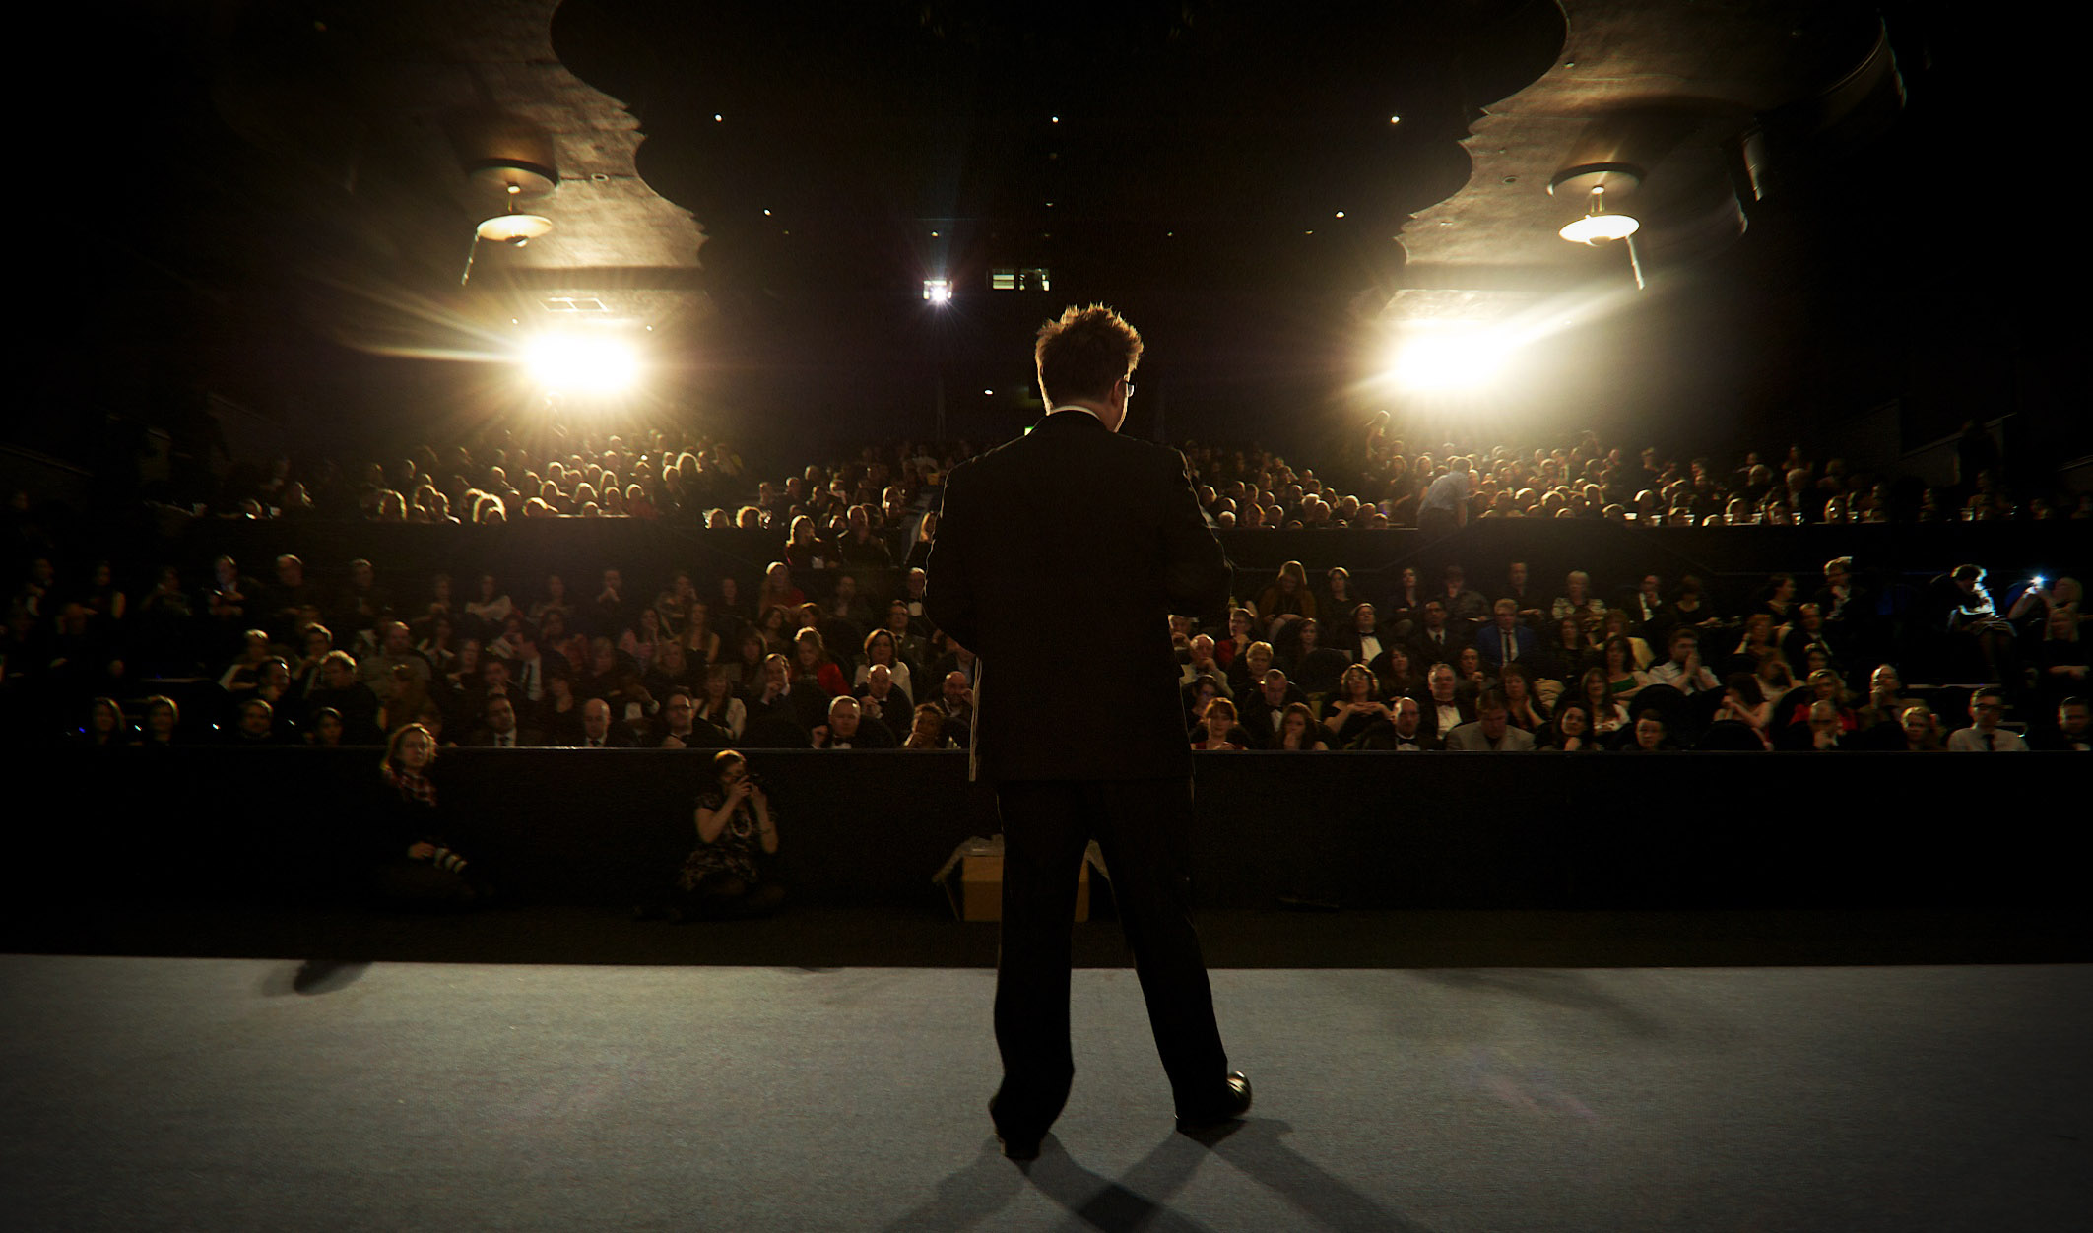
Then Chris Jones returned to the helm to present 13 special achievement awards for outstanding achievement in the following fields:

Best Cinematography – winner Marc Greenfield for ‘Practice Makes Perfect’
Best Performance – winner Elizabeth Croft for ‘A Kiss Goodbye’
Best Production Design – winner Laura kettle for ‘Neil’
Promo Music Award – Tess Tyler for ‘Stunt Poetry’
Best Music – Daniel Pemberton for ‘Neil’
Best Sound Design – Simon Reglar and Ben Baird for ‘Neil’
Best Song – Fuzzy Jones for ‘Swan’
Best Editing – Anil Rao for ‘Neil’
Guerilla Film Award – Phil Peel for ‘Love’
Best Director – Staré Yildirim for ‘That Good Night’
Best Picture – Evan and Kerry Marlowe for ‘Smasheroo’

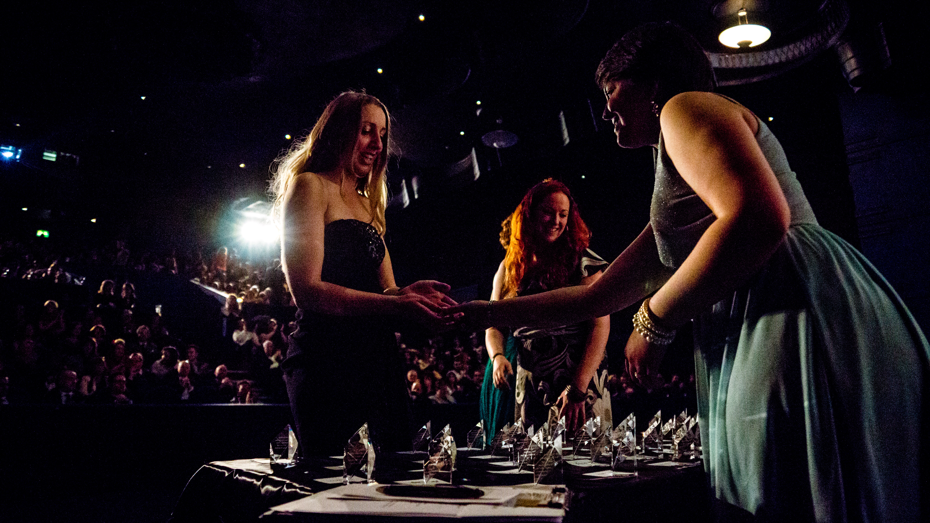
Winner of the Audience favourite award (as voted on the night) was ‘Beryl’ by Screenwriter Sarah Page, directed by Deepak Verma at Capital City.

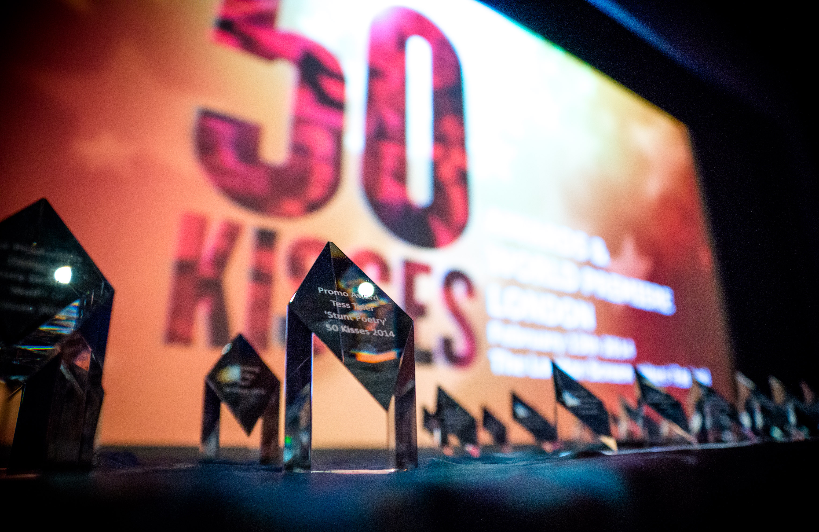
The Awards Ceremony drew to a close, the lights dimmed and the 50 Kisses opening credits rolled for the first time to a capacity audience that cheered and applauded all the films, paying tribute to the talent and hard work that went into each and every one of them.

90 minutes, 25 short films, over 2000 credits and 50 Kisses later the audience spilled back out into the bar for drinks, networking and more photo opportunities late into the night. To take home from this amazing night to remember, everyone received a free copy of the official 50 Kisses UK Quad poster.

For it’s one day release on one screen, 50 Kisses took £9,436.35 at the UK Box office, proving itself a serious contender on one of the busiest weekends of the year in the film calendar.

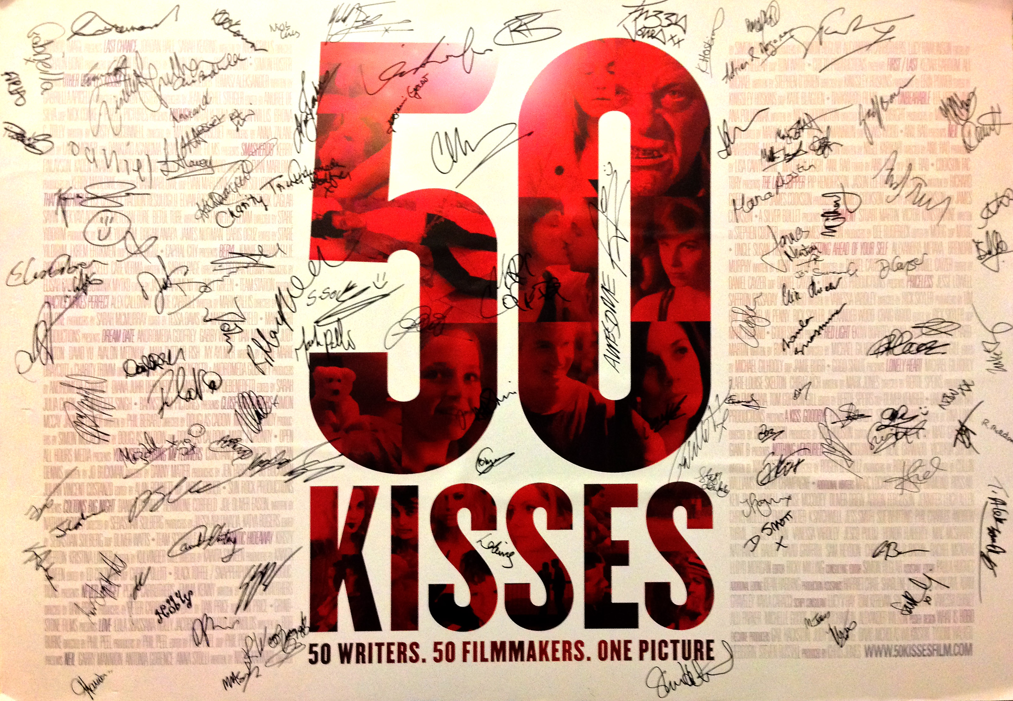
Update – March 2014:
Following the World Premiere, 50 Kisses, submitted a claim to the Guinness Book Of World Records for the title ‘Most Co-Writers on a feature film’.

With the World Premiere serving as evidence of a ‘feature film release’ along with BBFC Classification and Box Office Revenue, 50 Kisses is qualified in it’s category and hopes to smash the current record holder Forever And A Day (1943) which has 21 writers credited.

We expect to receive news on whether 50 Kisses will join this exclusive group of World Record Holders any day now…

The Players

Chris Jones – Director
Chris Jones is passionate about all things film. He has spent his life watching movies, making movies and helping others make their movies. His projects include action thriller ‘The Runner’, serial killer thriller ‘White Angel’, paranormal horror ‘Urban Ghost Story’ and the multi-award winning and Oscar Shortlisted ‘Gone Fishing.

In addition to running the London Screenwriters Festival, now the largest festival of it’s kind in the world, Chris co-created and authored The Guerilla Film Makers Handbook series of best selling books and runs regular film making workshops for filmmakers.

Why did you decide to make 50 Kisses?
“Having made shorts, feature films, written the Guerilla Film Makers Handbooks, trained thousands of filmmakers and run The London Screenwriters’ Festival, I have seen a pattern emerge among creatives. For one reason or another, many emerging screenwriters and filmmakers find it difficult to get that all important first credit on a large scale project, one that get lots of press, IMDB listings, real world reviews and massive internet activity. That’s why we came up with ’50 Kisses’”

David Wilkinson – Executive Producer and Distributor
David Nicholas Wilkinson, founder of the Guerilla companies and chairman of Distrify. He has a proven track record in film/TV and theatre production winning many awards; cinema/DVD/VOD/airline/TV/online distribution; book publishing as well as event management. He has produced and/or distributed almost 150 feature films.

David has also acted as a consultant on over 300 feature film projects for institutional financiers, individual investors and numerous film and television production companies seeking funding. He has chaired numerous film industry panels and events, has been a jury member of film festivals around the world and frequently appears in the press, radio & TV covering many aspects of the entertainment business.

The London Screenwriters Festival
The London Screenwriters Festival, now in its 5th year, is the largest event for professional screenwriters on the planet. For those serious about their screenwriting career, the London Screenwriters Festival is THE point on the calendar. For three days in October the industry’s top professionals descend on Regent’s University in London for an intense and immersive set of lectures, seminars, workshops, script pitches and networking opportunities. Whether a experienced screenwriter, or an aspiring one, the London Screenwriters Festival offers unparallelled access to speakers, educators, show-runners, executives and decision makers from the UK and beyond.

The London Screenwriters Festival has a number of talent development schemes, 50 Kisses has been far and away the most successful. It has brought writers and directors together from around the globe and encouraged collaboration at the grassroots. We already know of several partnerships who are developing work beyond the initiative and are planning more schemes like it in the future.

The Writers and their scripts

50 Two page scripts were chosen from the 1870 entries we received. Below are the featured writers, and what their script is about.

- 60 Year Valentine by Marc Lockier.
A couple dance their way through the landmark moments of their lives together.

- A Glasgow Kiss by Lawrence Diamond.
A Glaswegian’s first trip to London doesn't quite go as planned.

- A Kiss Goodbye by Tina Lowe.
A philandering businessman thinks he can have it all, but his jilted secretary has other ideas.

- Advice by Ross Aitken.
A likely lad hoping to ask the woman of his dreams out gets all manner of bad advice from his friends.

- Beryl by Sarah Page.
An old lady shares a 'moment' with a handsome young nurse in a care home.

- Boxes by Rhys Howell.
A man talking to the voice of his dead wife is about the join her.

- Close Encounters by Phil Berard.
Two exes meet in the street, but what they say and what they mean are two entirely different things.

- Cloudy Days by Louise McCooey.
A father takes care of his disabled daughter on Valentine's day.

- Colton's Big Night by Nathan Gower.
A ten year old competes with his babysitter’s teenage boyfriend for her heart.

- Countdown by Oliver Drew.
An explosives expert risks his own life to save a girl trapped by a Valentine’s Day bomb.

- Don't by Arron Ferguson.
Two people on different ledges are about to commit suicide - can they find love in the most unlikely of places.

- Dream Date by Anne-Marie Draycott & Charity Trimm
A couple check into a hotel for some quality time together...

- Enough by Kirsty McConnell
A soon to be married woman has a "what if" conversation with an ex. WINNER – Best Screenplay.

- First, Last, Best by Jennifer Leigh Allen.
A woman shares kisses of every size, shape and form before finally finding love.

- First/Last by Stephen O'Brien.
In a world where kisses can literally kill, a couple risk everything for the perfect valentines night.

- Her…and Him by Chris Mueller.
Cupid, omnipotent and bored, sets up two mismatched partygoers.

- I'll Stand by You by Emily Salter.
Matt and Hannah's Valentines date is interrupted when the babysitter calls.

- Jealous Making by K Satchwell.
A couple fake an elaborate romance to show their exes what they're missing.

- Kisses from Jessica by Jess Smith.
A hooker saves Valentines Night for her favourite client…at least he thinks he is.

- Last Chance by Nick Grills.
Martin overplans when asking his secret crush out - but her answer encourages him to calm down.

- Lonely Heart by Mark Jones.
In the Zombie apocalypse, nothing says I love you like eating the heart of your true love.

- Love by Rob Burke.
A man on a bus receives a powerful valentine from a little girl.

- Love Letters by Sue Whitting.
Does our heroine need glasses to find love?

- Lunchtime by Phil Charles.
A shy security guard tries to pluck up the courage to ask out the sandwich man of his dreams.

- Neil by Nigel Karikari.
On the most manufactured 'holiday' of the year, can love be manufactured?

- Never Forget by Peter Carruthers.
A scorned husband sends his wife a firm and unforgettable message.

- Nothing Ventured by Nina Haerland.
A florist helps a man pick out last minute flowers on Valentines day.

- On thy Cheeks a Fading Rose by Andrew Turvil.
Two tramps give an unloved rose an unexpected home on Valentine’s Day.

- One (distinctly average) Date Later… (Title changed to “Getting ahead of yourself”) by John Thornton.
John plays mind games with himself during a bus ride with his upset girlfriend.

- Other Peoples Kisses by Gabriella Apicella.
An older drunk woman comes to the rescue of a younger girl who is being harassed by a would be Valentine.

- Poster Boy by Tracey Flynn.
A socially uncomfortable woman takes a picture of a man she meets at the bus stop and discovers he was trying to pass her his number.

- Practice makes perfect by Mark Pallis.
Clint anxiously practices kissing only to find a soft peck on the cheek does just fine.

- Priceless by Vanessa Yardley.
Egged on by his friends a nervous young man approaches a prostitute on a dare.

- Proof of Love by Jesco Puluj.
Two shy singletons pretend to be a couple of order to gain free entry to a Valentine’s Club night.

- Red Light by Ryan La Via.
A woman takes a fancy to the man in the car next to her as they wait at the lights.

- Romantic Hideaway by Kulvinder Gill.
A middle-aged man treats his trophy wife to breakfast in bed on Valentine's Day.

- Sloppy Snogs by Honor Flaherty.
A homeless man benefits from a drunken couples argument.

- Smasheroo by James Howard.
A woman who has suffered a head injury is tended to by her concerned husband.

- SWALK by Mac McSharry.
A grieving young man shares one last kiss with his wife.

- That good night by Kenneth J Lemm.
An elderly man, close to death, finds an unexpected reason to live on Valentine’s Day.

- The Cyclist by David Griffith.
A cyclist comes to the aid of a young woman being given a hard time by her brute of a boyfriend.

- The Great Kiss Heist by Nathanael Bauer.
A six year old with a crush on his teacher executes a MacGyver style plan to steal a kiss.

- The Last Supper by Richard Green.
An old tramp sacrifices his last worldly possession so he can treat his wife to a romantic meal on the streets.

- The Moment by Stephen Cooper.
A hitman has a moment with his target.

- The Nearness of you by Sam Heydon.
During WWII an illicit affair is stopped dead in it's tracks.

- Tied Up by Christopher D Bacon.
A random act of kindness might make a man late for his Valentine's dinner but it makes him a hero in his lover’s eyes.

- Unbearable by Nick Luddington.
Two cuddly toy bears bare the brunt of a relationship break up when the couple that own them split up.

- You used to bring me flowers by Jo Buckman.
A woman attempts to re-kindle lost love with her…exceptional ex.

- Price of Romance by Rachel McAdam.
A supermarket check out takes action to get rid of a potential love rival when it takes a fancy to its operative.

- A Ghetto Punk Romance by Lloyd Morgan.
A modern day Bonnie and Clyde talk love and Valentine's on the way to rob a bank.

The Directors and their films
Every one of the 127 films entered into the competition will be featured, in some form, in the film. However, there are 25 films which clearly stand out and which are played in their entirety. These are:-

- Beryl by Deepak Verma
This version of Beryl combines the mischievousness of the script with some great acting, making a wonderful tight little short.

- Colton’s Big Night by Sebastian Solberg.
Sebastian captures the wonder and magic of being in love for the first time, even if it is not always convenient.

- Dream Date by Andromeda Godfrey and Diana Juhr De Benedetti.
A brilliant, sexy and sassy short, that misdirects the viewer and pays off well.

- Enough by Maureen Hascoet.
Maureen’s take on “Enough” is an emotional gut punch and an ode to the “what ifs” and “if onlys”. Maureen’s film features a star turn by actress Natalia Tena, best known for her roles in the ‘Harry Potter’ movies and HBO’s ‘Game Of Thrones’.

- First/Last by Kingsley Hoskins.
This version of First/Last is raw, honest and shows real talent in upcoming director Kingsley Hoskins.

- A Kiss Goodbye by Baz Hodson.
A kiss goodbye is a tension filled thriller, well visualised and acted.

- Last Chance by Shaun Bond.
This is a well observed look at a sweet, if not slightly embarrassing moment.

- Lonely Heart by Bertie Spears.
Great low-budget filmmaking, combining fab FX makeup and some well thought through visuals.

- Love by Phil Peel.
An ambitious, brave and confident take on a the script. Phil has gone on to win awards for this impressive interpretation of a bold and topical story.

- Neil by Simon Reglar.
Simon’s beautifully realised film, brings real heart to a interesting script.

- Neil by Anil Rao.
Anil’s take on Neil was completely different and by far the most “authored” of the directors. Well done.

- Never Forget by Peter Carruthers.
A gritty tense short with one hell of a twist ending.

- One (Distinctly Average) Date Later/AKA Getting ahead of yourself by Dan Cazyer.
Dan’s take on Getting ahead of yourself brings a whole different level to the project.

- Other People’s Kisses by Simon Foster.
Gritty, well authored and well acted, Other People’s Kisses is a welcome addition to the 50 Kisses project.

- Practise Makes Perfect by Vance Malone.
Shot in RED in LA, Practise makes perfect is a beautifully realised and well acted piece, showcasing major international talent.

- Priceless by Rick Skyler.
A touching portrayal of a great script, Rick Skyler’s priceless captures the warmth and hopelessness of the situation the young protagonist finds himself in.

- Red Light by Michael Gilhooly.
This version of Red Light has all the warmth and humour of the script, twisted ever so slightly for the big screen.

- Romantic Hideaway by Kawita Sareen.
Twisting the script just slightly, Kawita Sareen and Screenwriter Kulvinder Gill are now working on a feature length version of Romantic Hideaway.

- Smasheroo by Evan Marlowe.
Insightful and impactful, Evan Marlowe’s take on this love story post head trauma is incredibly engaging.

- That Good Night by Stare Yiddrim.
Made in Turkey by up and coming director Stare Yiddrim, That Good Night embodies the international aspect of the 50 Kisses project.

- The Last Supper by James Cookson.
Gritty, authentic and well made, James Cookson’s “The Last Supper” is a real treat.

- The Moment by James Newton.
The Moment was by far the most popular film to make, James Newton’s version is a cut above the rest balancing humour, tension and just the right amount of sexy.

- Unbearable by Mark S Wright.
Beautifully realised vision of a love story told through the coming together and separation of teddy bears.

- You used to bring me flowers by Jen Farrow.
Great short, set in Australia and starring Neighbours Stefan Dennis, spawns a new genre – the Rom-Zom.

- Close Encounters by Douglas Caldow & Marc J Grundy.
Great production values and performances realised from the Scottish based team in this well executed version of a wonderfully subtle and nuanced script.

